Steps must be followed to set up an Amazon EKS (Elastic Kubernetes Service cluster using the AWS Management Console

1. Create an IAM Role with permissions for Amazon EKS and attach policies like AmazonEKSClusterPolicy and AmazonEKSServicePolicy to the role to grant necessary permissions for cluster creation and management
2. Create a VPC service in the AWS Management Console
3. Install eksctl, the official CLI tool for Amazon EKS, by following the installation instructions provided in the official documentation <https://docs.aws.amazon.com/cli/latest/userguide/getting-started-install.html>

To set up an Amazon EKS (Elastic Kubernetes Service) cluster using the AWS Management console:

1. Use eksctl to create an EKS cluster and define the cluster configuration in a YAML file or pass parameters directly
2. Depending on the requirements and use case, the user might need to configure additional settings such as networking, logging, monitoring, and security

CLI Commands

Confirm the installation with the following command: aws –version

aws-cli/2.27.31 Python/3.13.3 Linux/6.1.134-152.225.amzn2023.x86_64 exe/x86_64.amzn.2023

aws configure

**Check to confirm EKS cluster is running:**

aws eks --region us-east-1 describe-cluster --name EKSCluster --query cluster.status  
aws eks describe-cluster --name EKSCluster2 --region us-east-1

aws eks --region us-east-1 update-kubeconfig --name EKSCluster2

kubectl get svc

kubectl get nodes --watch

kubectl delete deployment nginx-deployment

AmazonEKSWorkerNodePolicy

AmazonEKS_CNI_Policy

AmazonEC2ContainerRegistryReadOnly

**To install** the AWS CLI, run the following commands.

**curl "https://awscli.amazonaws.com/awscli-exe-linux-x86_64.zip" -o "awscliv2.zip"**

**unzip awscliv2.zip**

**sudo ./aws/install**

Log into AWS Management Console

Enter EKS and select Elastic Kubernetes Service

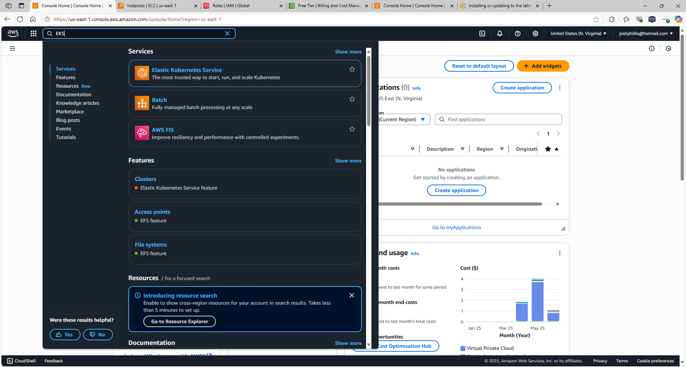

Select **Create cluster**

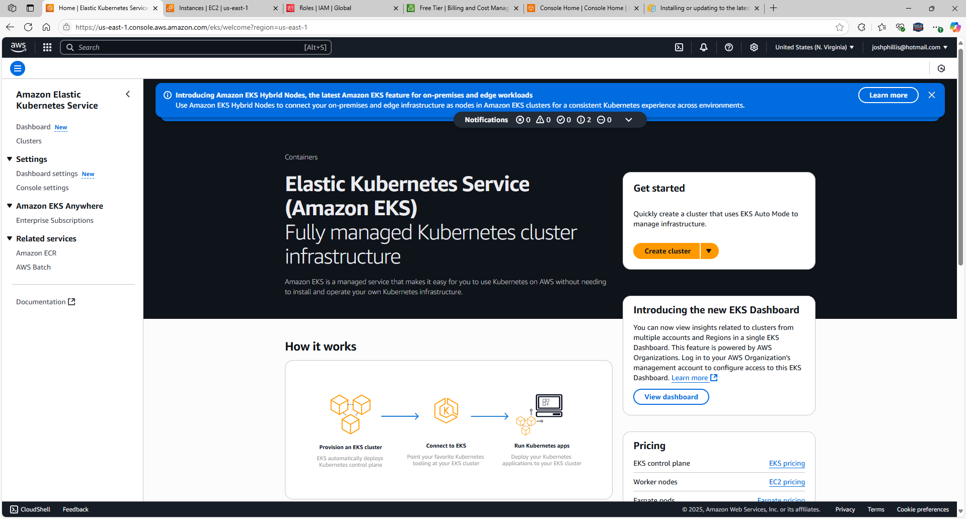

Select Create recommended role for Cluster IAM role

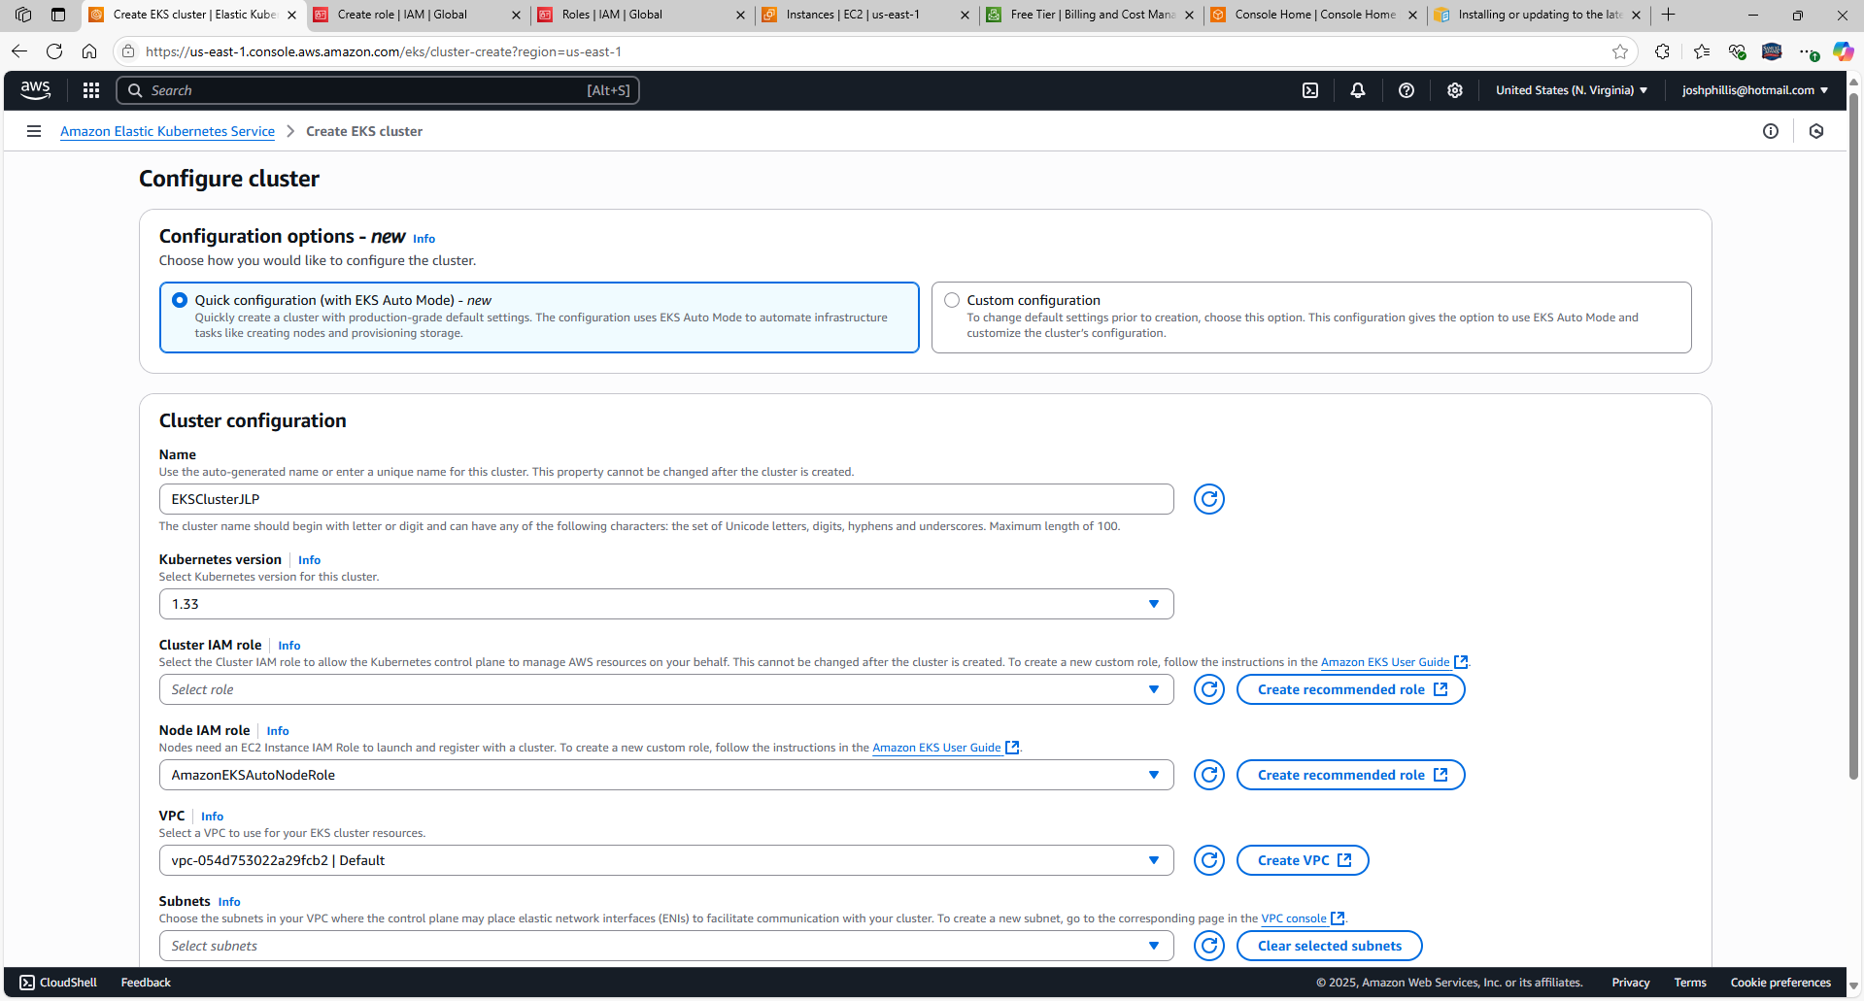

Trusted entity type: AWS service

Use case: EKS-Cluster

Scroll down, select Next

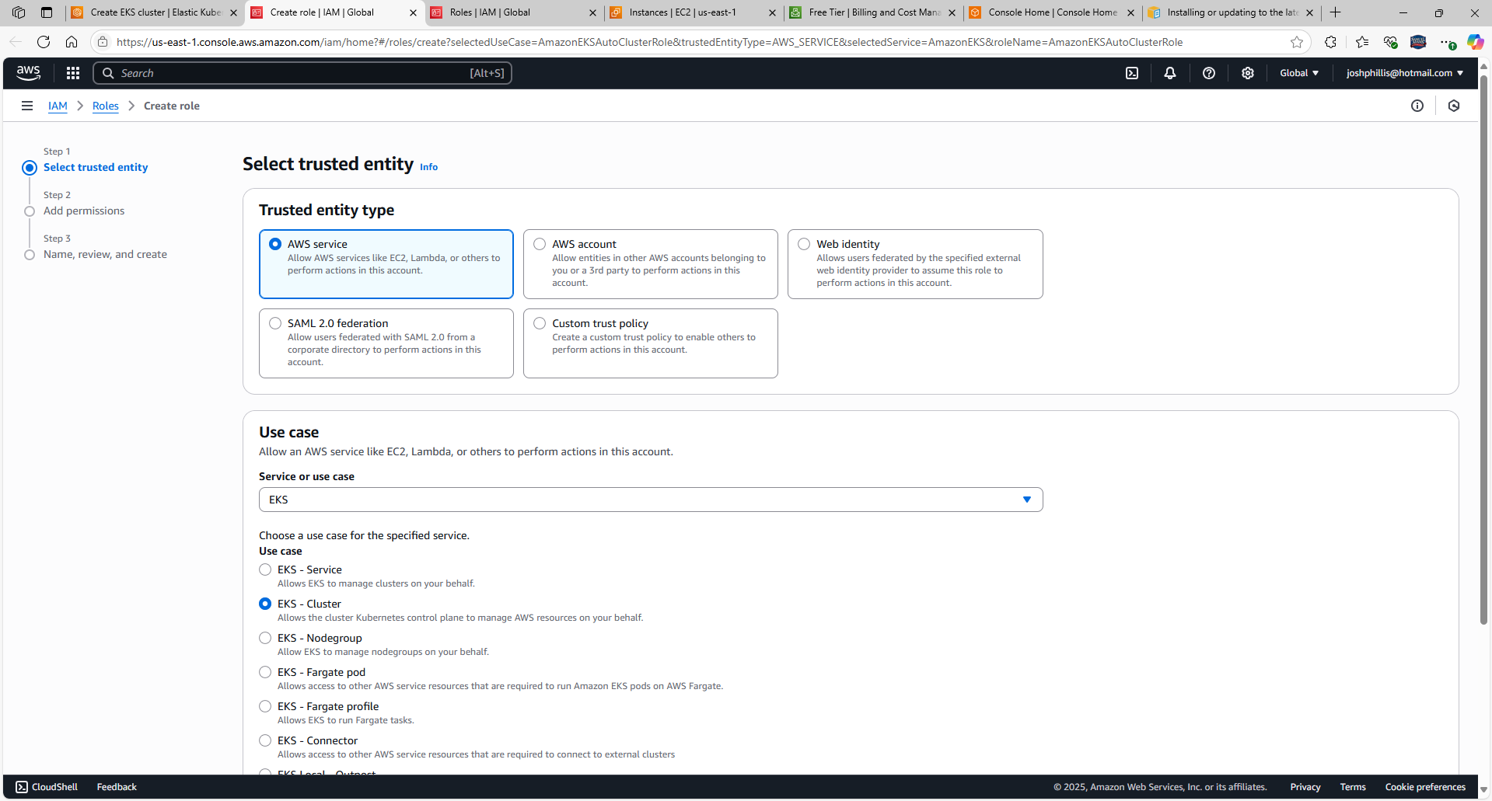

Permission policies: AmazonEKSClusterPolicy

Select Next

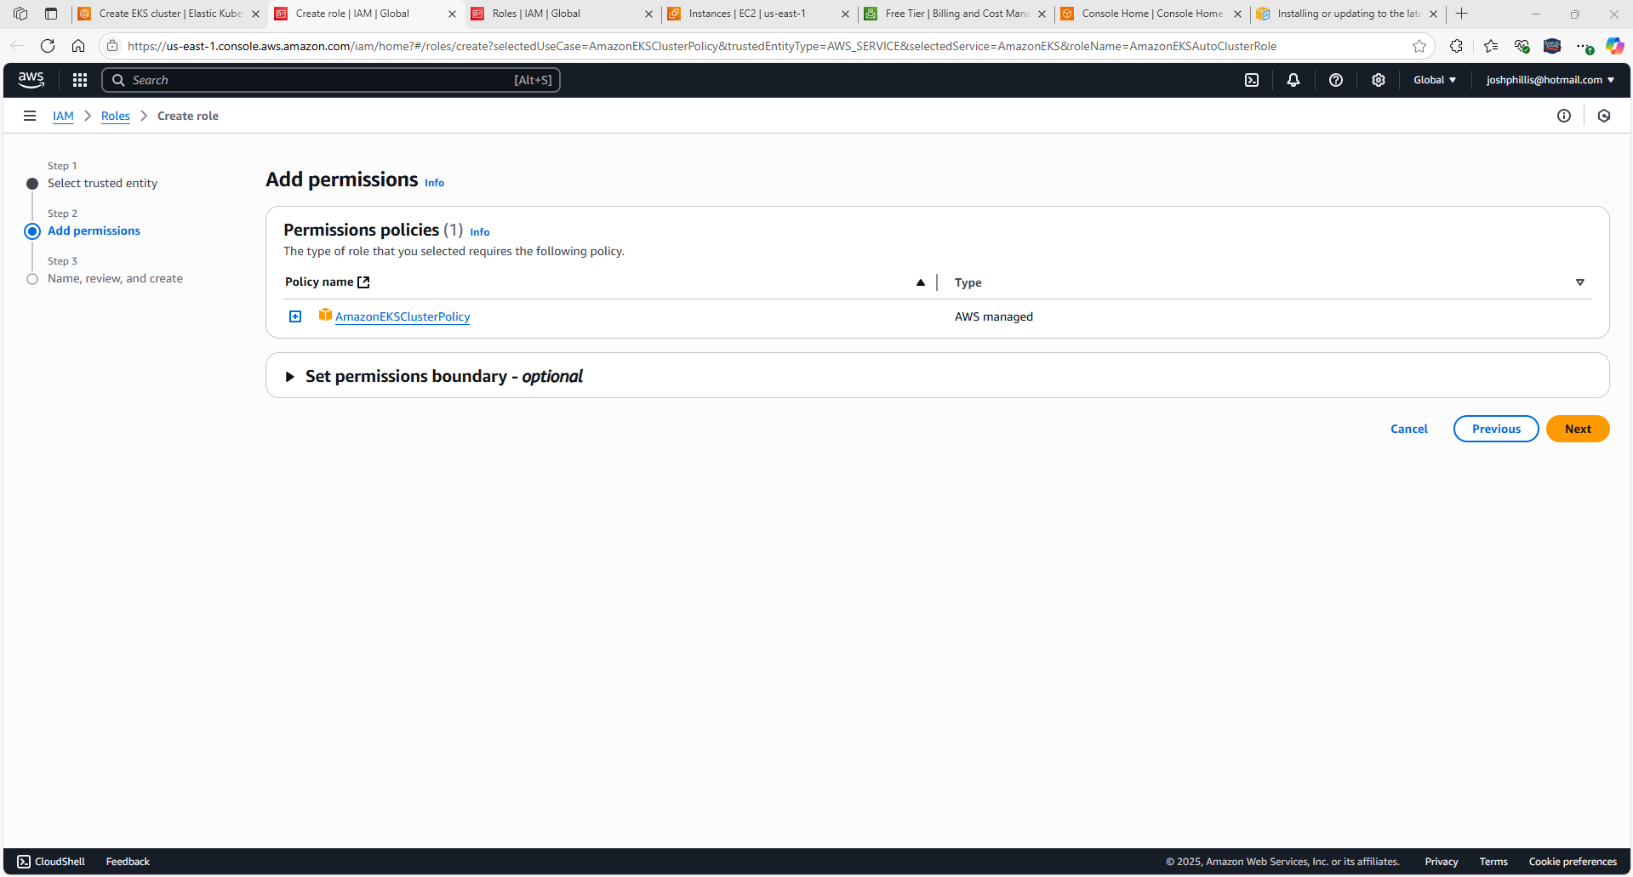

Role name: AmazonEKSAutoClusterRole

Line 8: “eks.amazonaws.com”

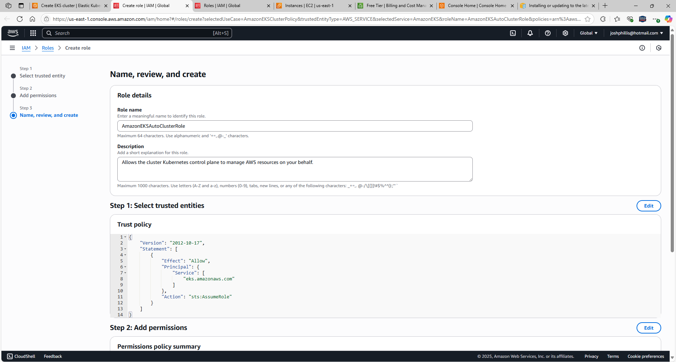

Scroll down, select Create role

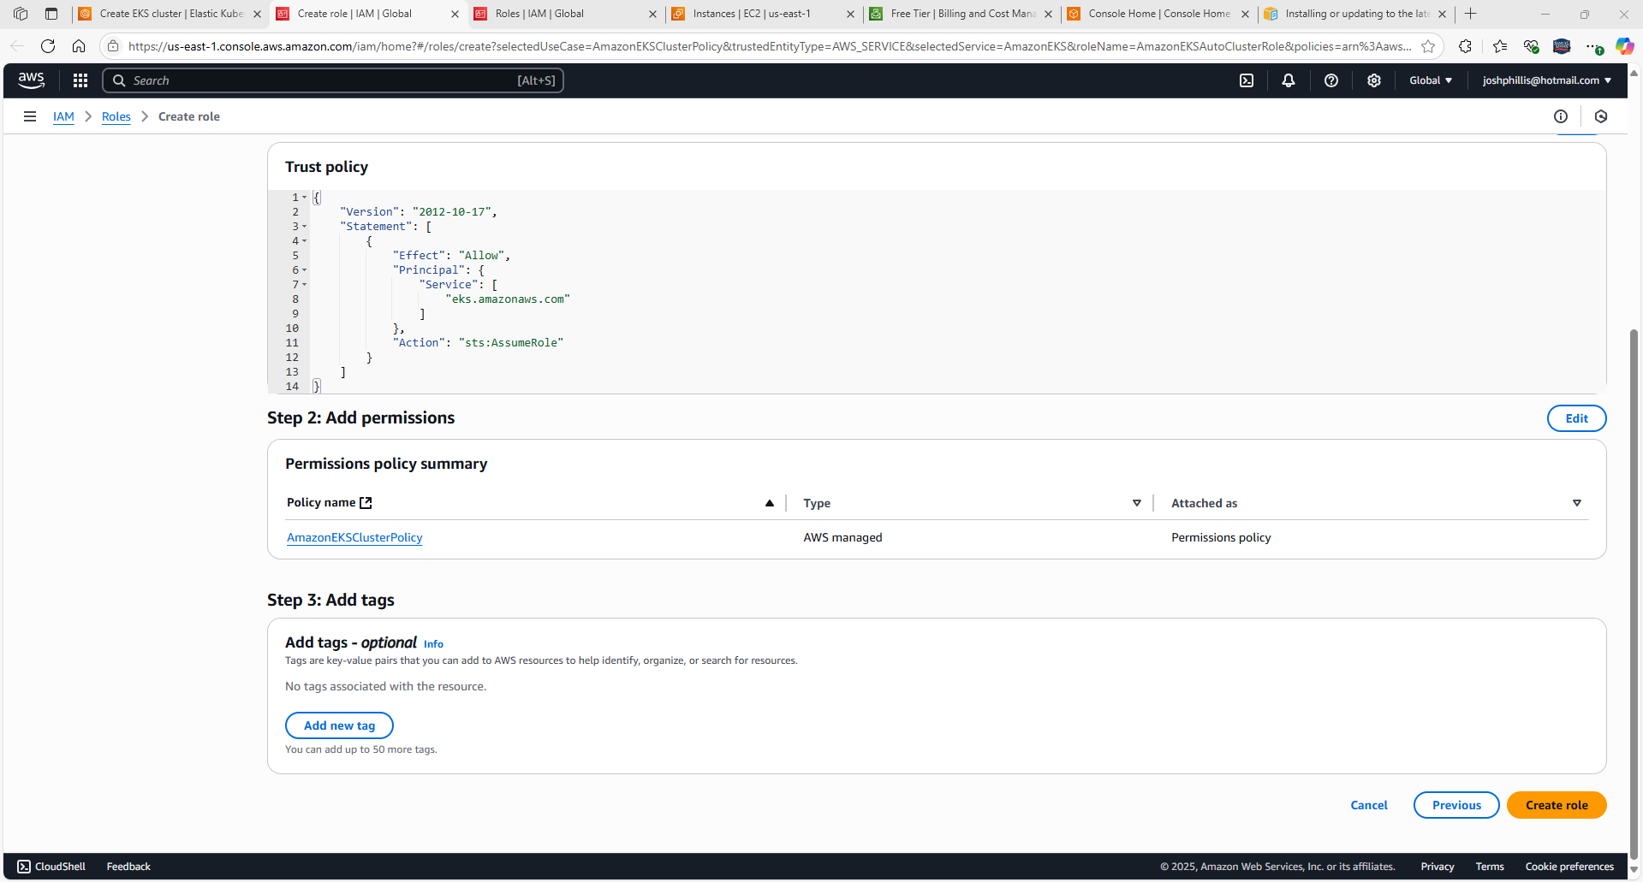

Return to Amazon Elastic Kubernetes Service page

Select “Refresh Role”

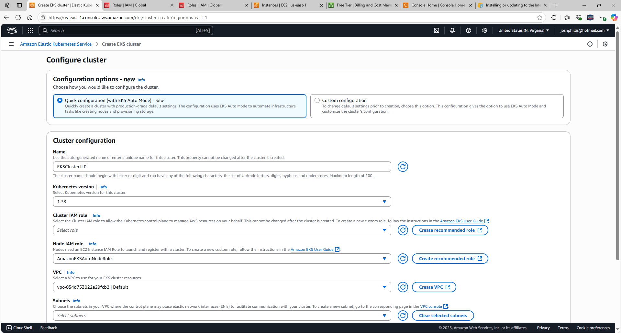

AmazonEKSAutoClusterRole created

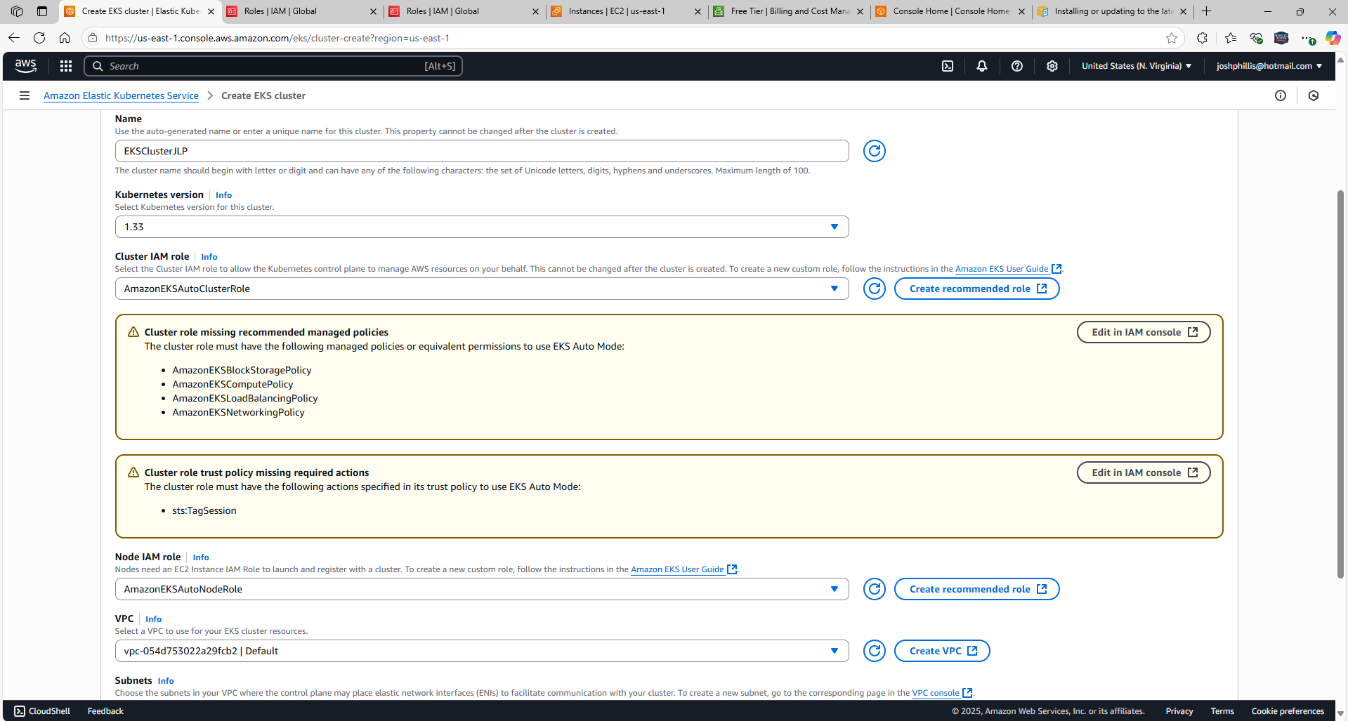

Select Edit in IAM console

Added AmazonEKSBlockStoragePolicy, AmazonEKSComputePolicy, AmazonEKSLoadBalancingPolicy, and AmazonEKSNetworkingPolicy

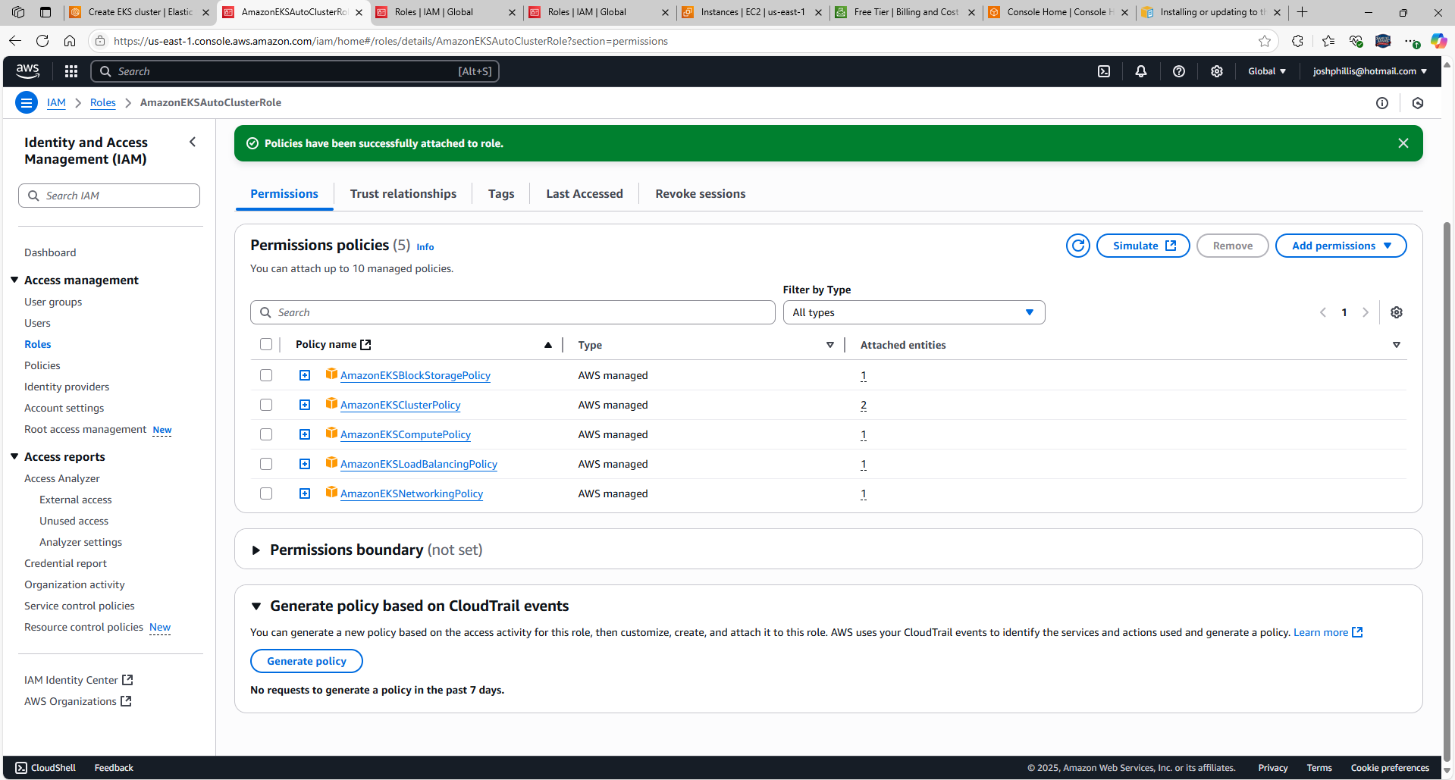

Created a Node IAM role and added to EKS Cluster. The note indicates that “Nodes need an EC2 Instance IAM Role to launch and register with a cluster.”

Removed 3 subnets. Out of 6, 3 subnets will be created.

Select Create

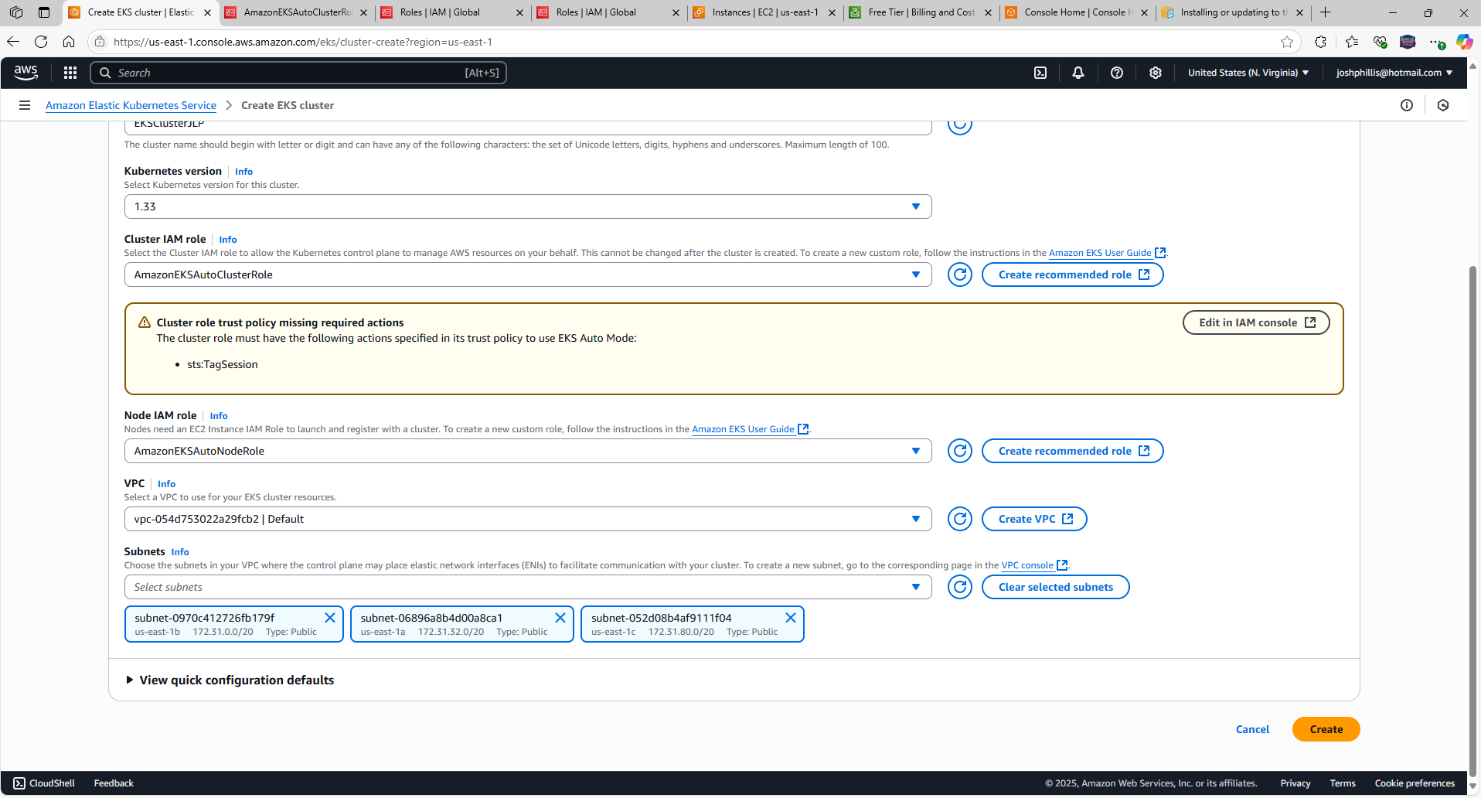

From EC2, create an instance

Select Launch instance

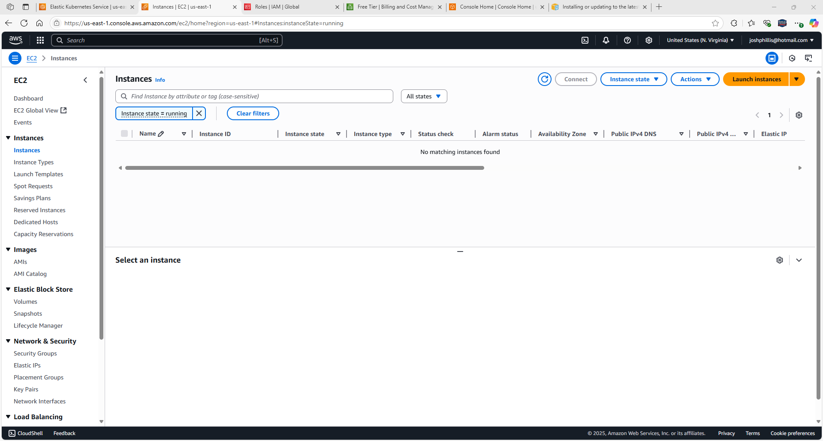

Instance name: EKSClusterJLP

AMI: Amazon Linux 2 AMI (HVM) – Kernel 5.10, SSD Volume Type (Free tier eligible)

Scroll down

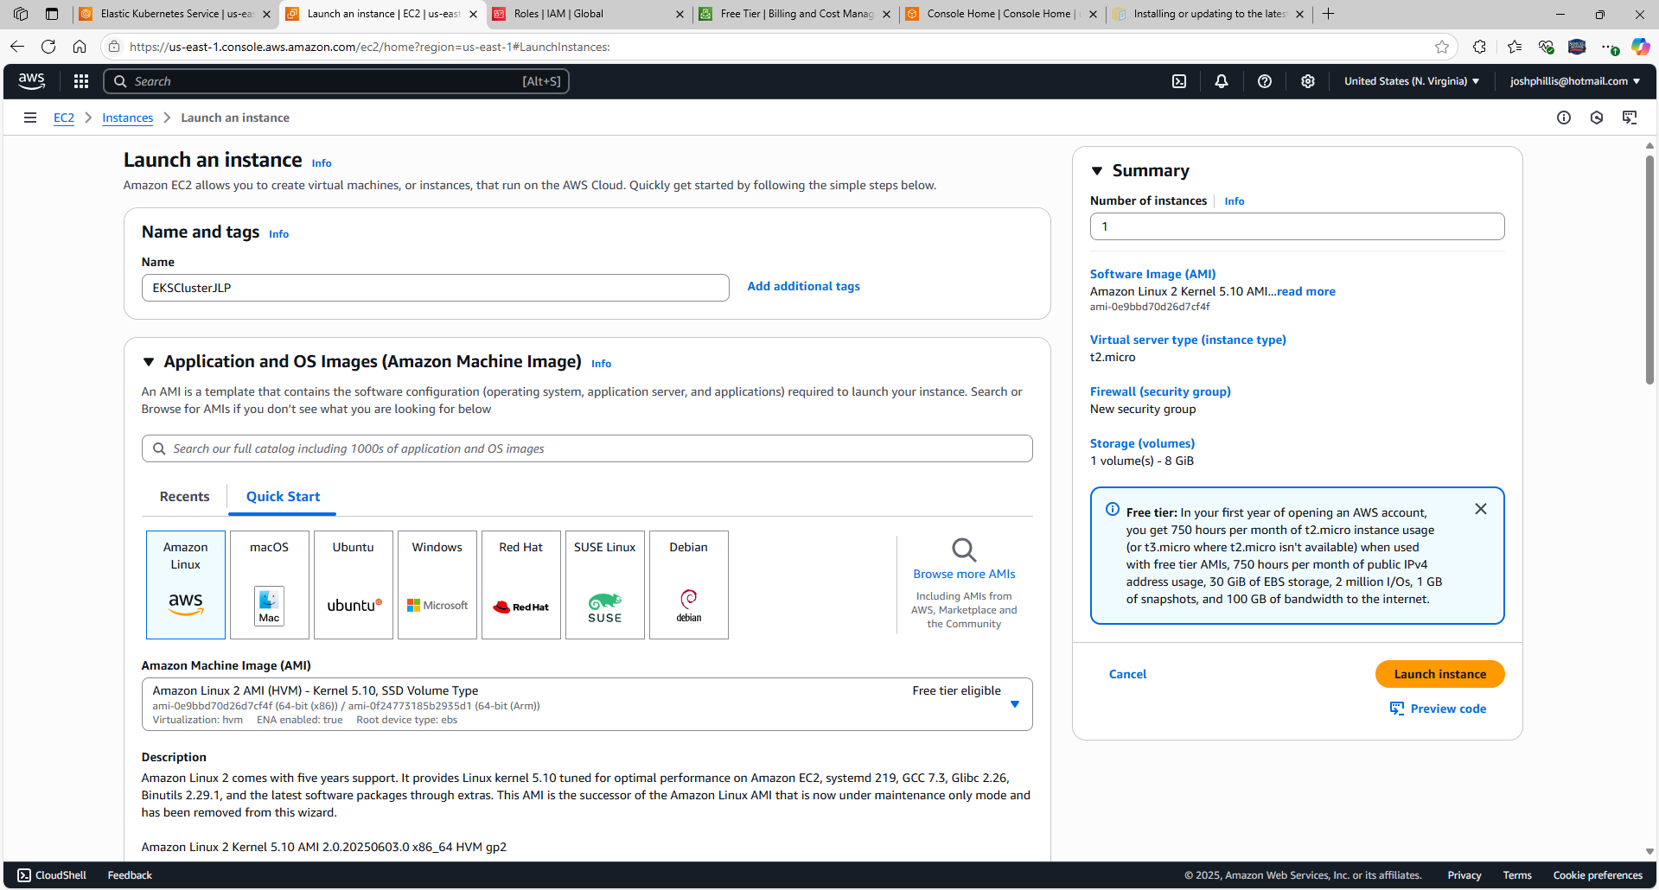

Instance type: T2.micro

Create a key pair: EKSCluster

Scroll down

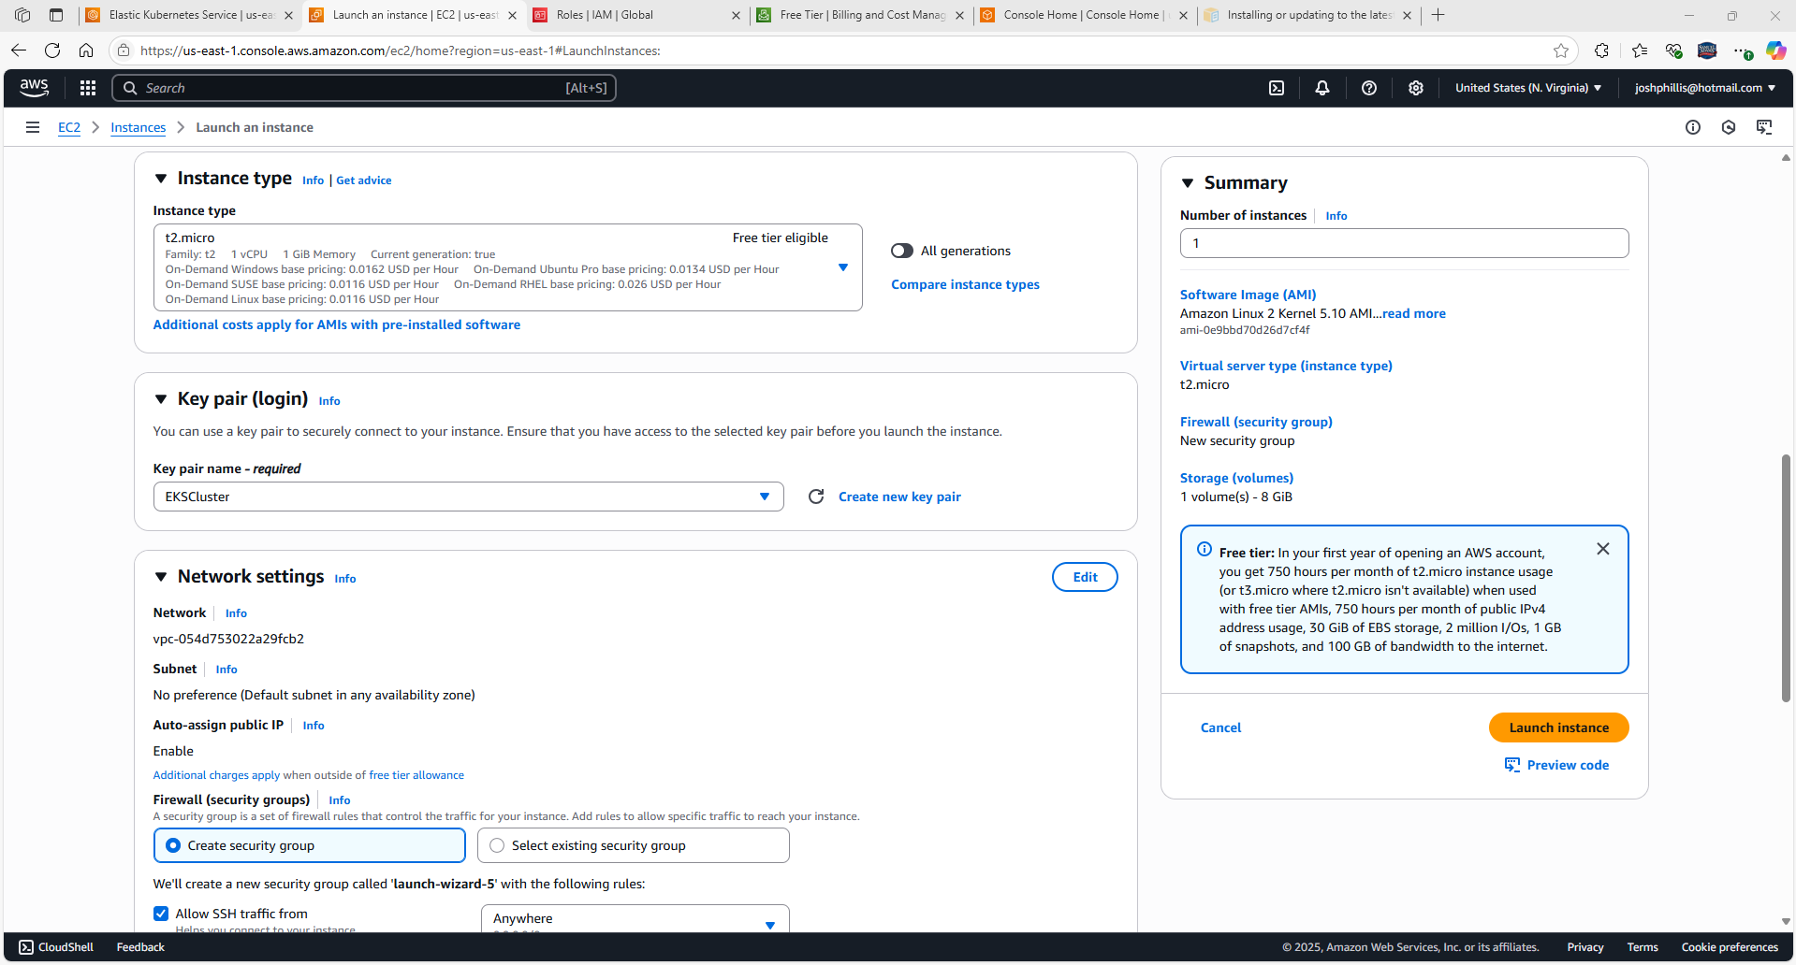

Select Allow SSH traffic from Anywhere

Select Allow HTTP traffic from the internet from Anywhere

Select Launch Instance

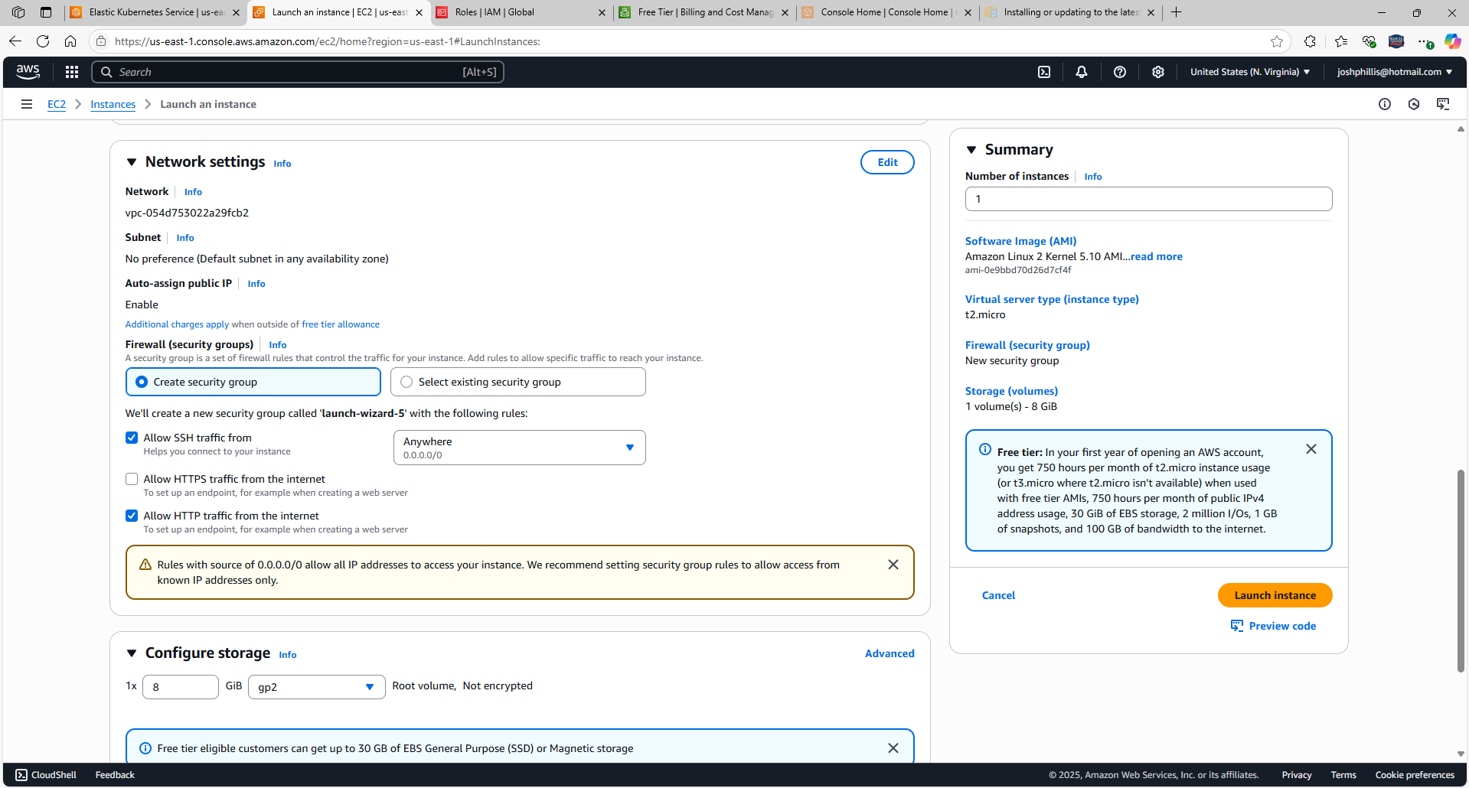

EKSClusterJLP is Active

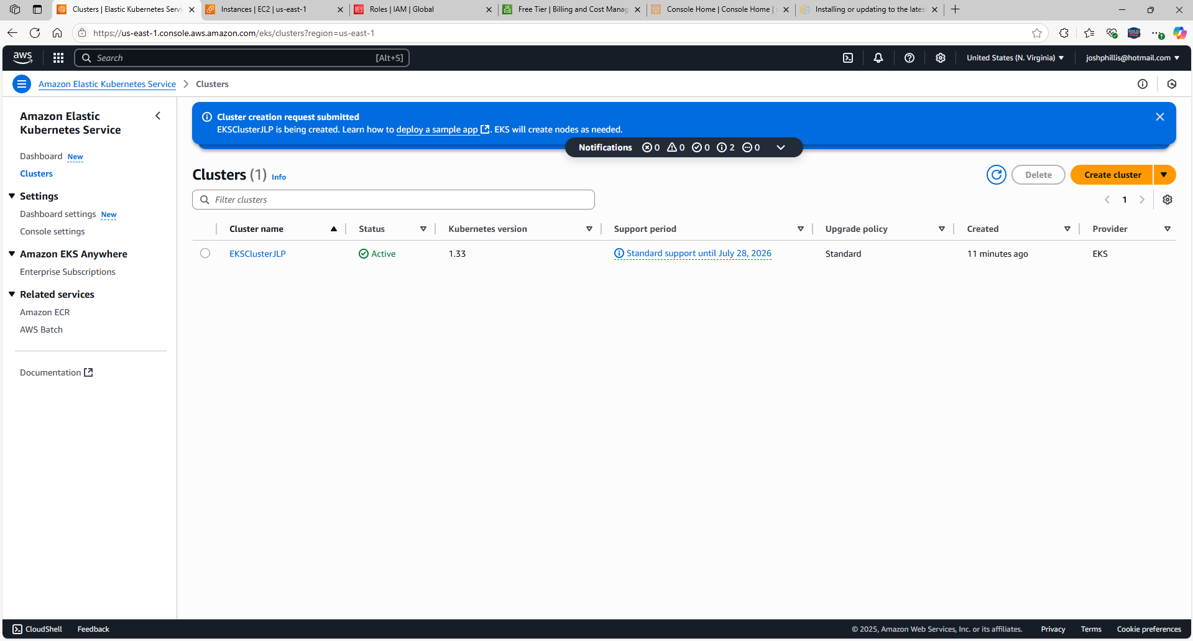

Instance is running

Select Connect

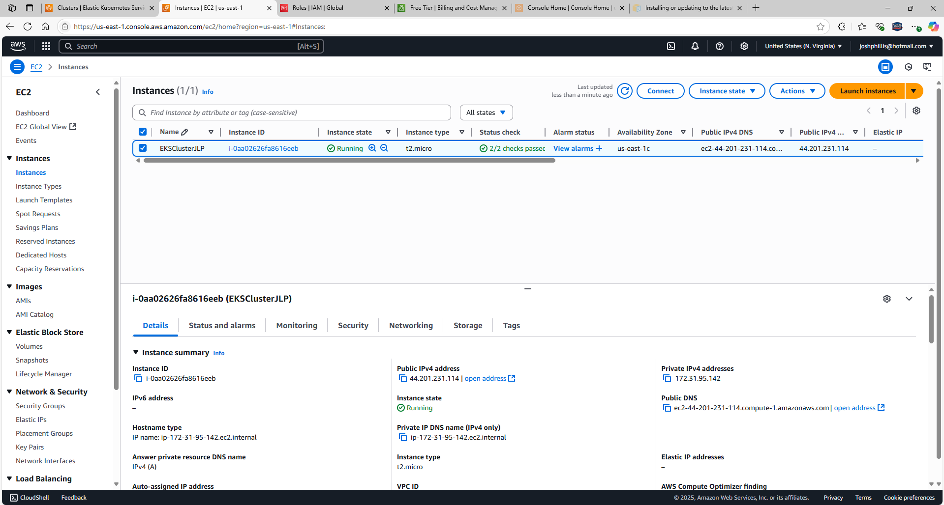

Select Connect

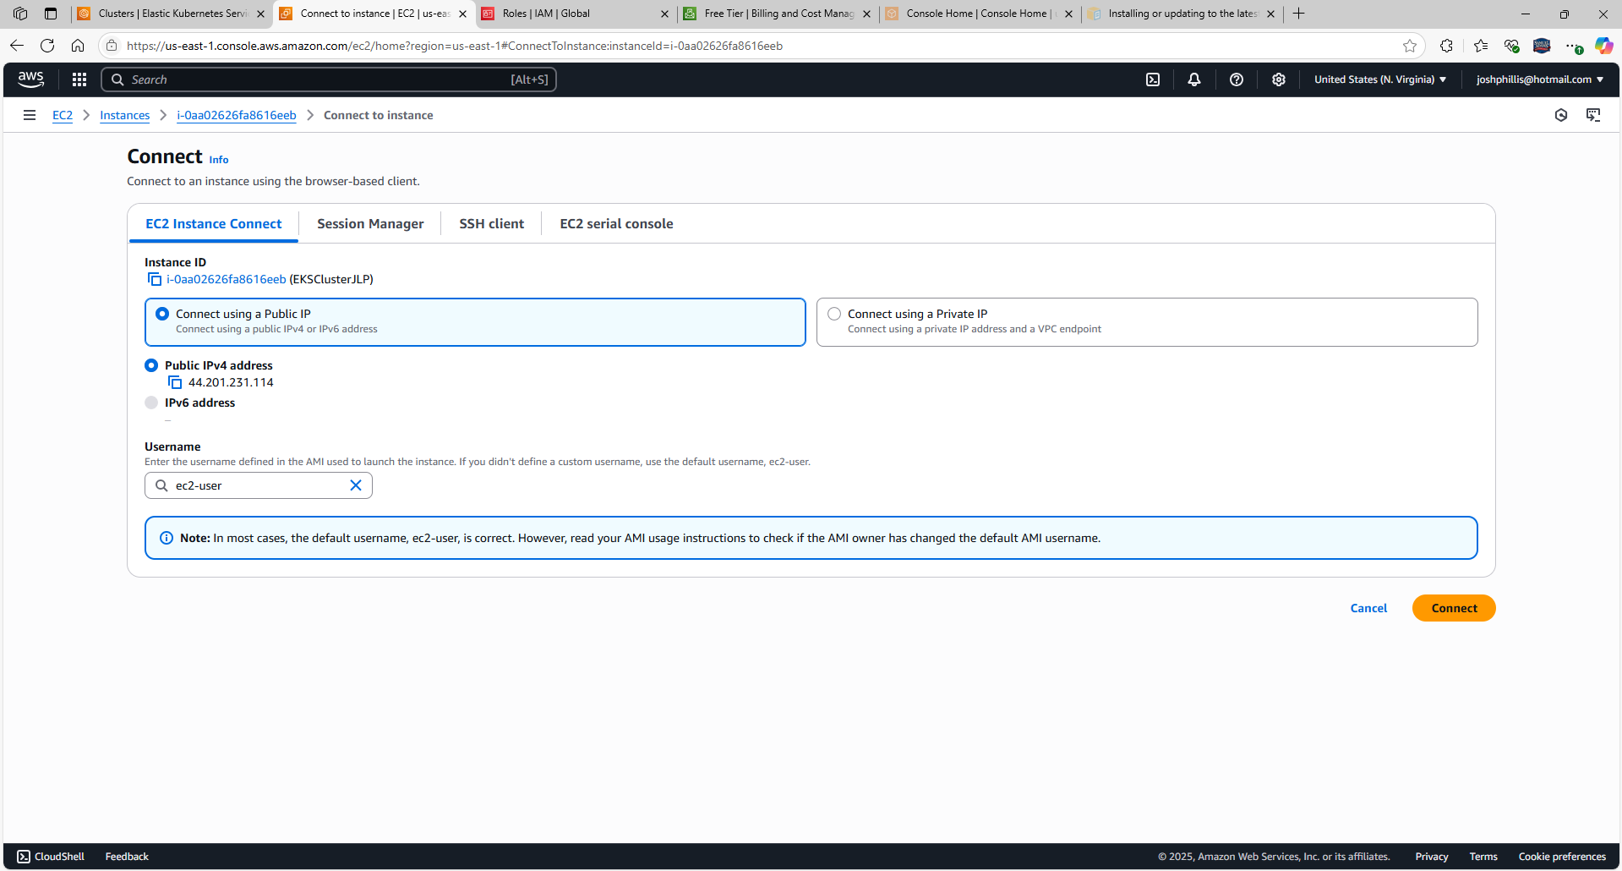

Connect to Amazon Linux 2 Instance

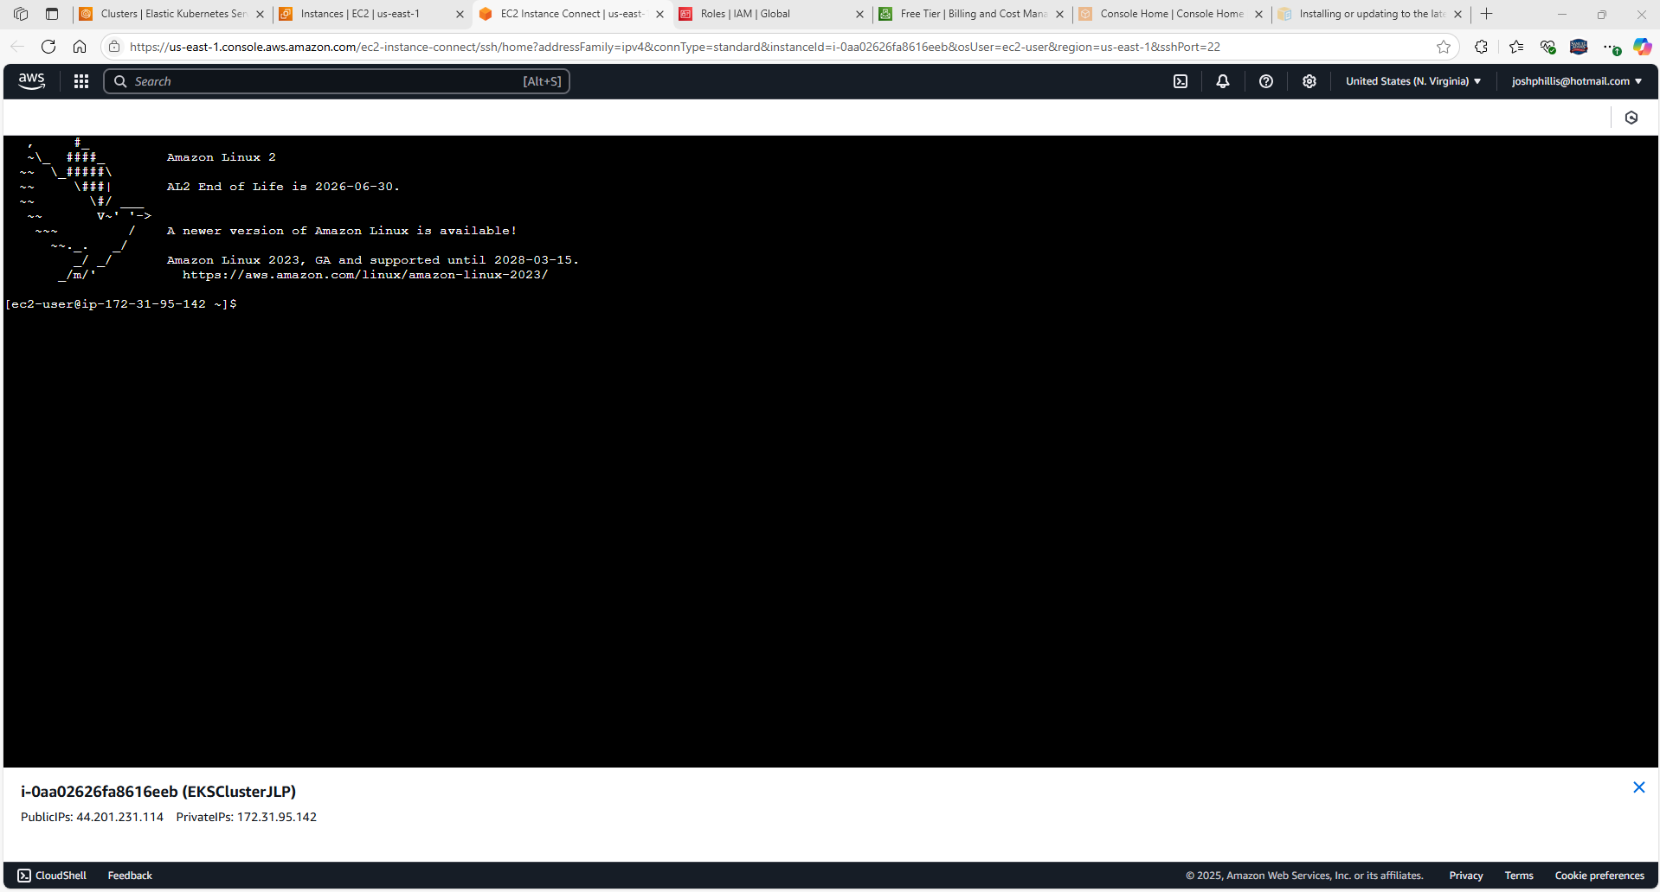

Navigate to [Installing or updating to the latest version of the AWS CLI - AWS Command Line Interface](https://docs.aws.amazon.com/cli/latest/userguide/getting-started-install.html) to install AWS CLI in the AWS Instance. <https://docs.aws.amazon.com/cli/latest/userguide/getting-started-install.html>

Scroll down, select curl "https://awscli.amazonaws.com/awscli-exe-linux-x86_64.zip" -o "awscliv2.zip"

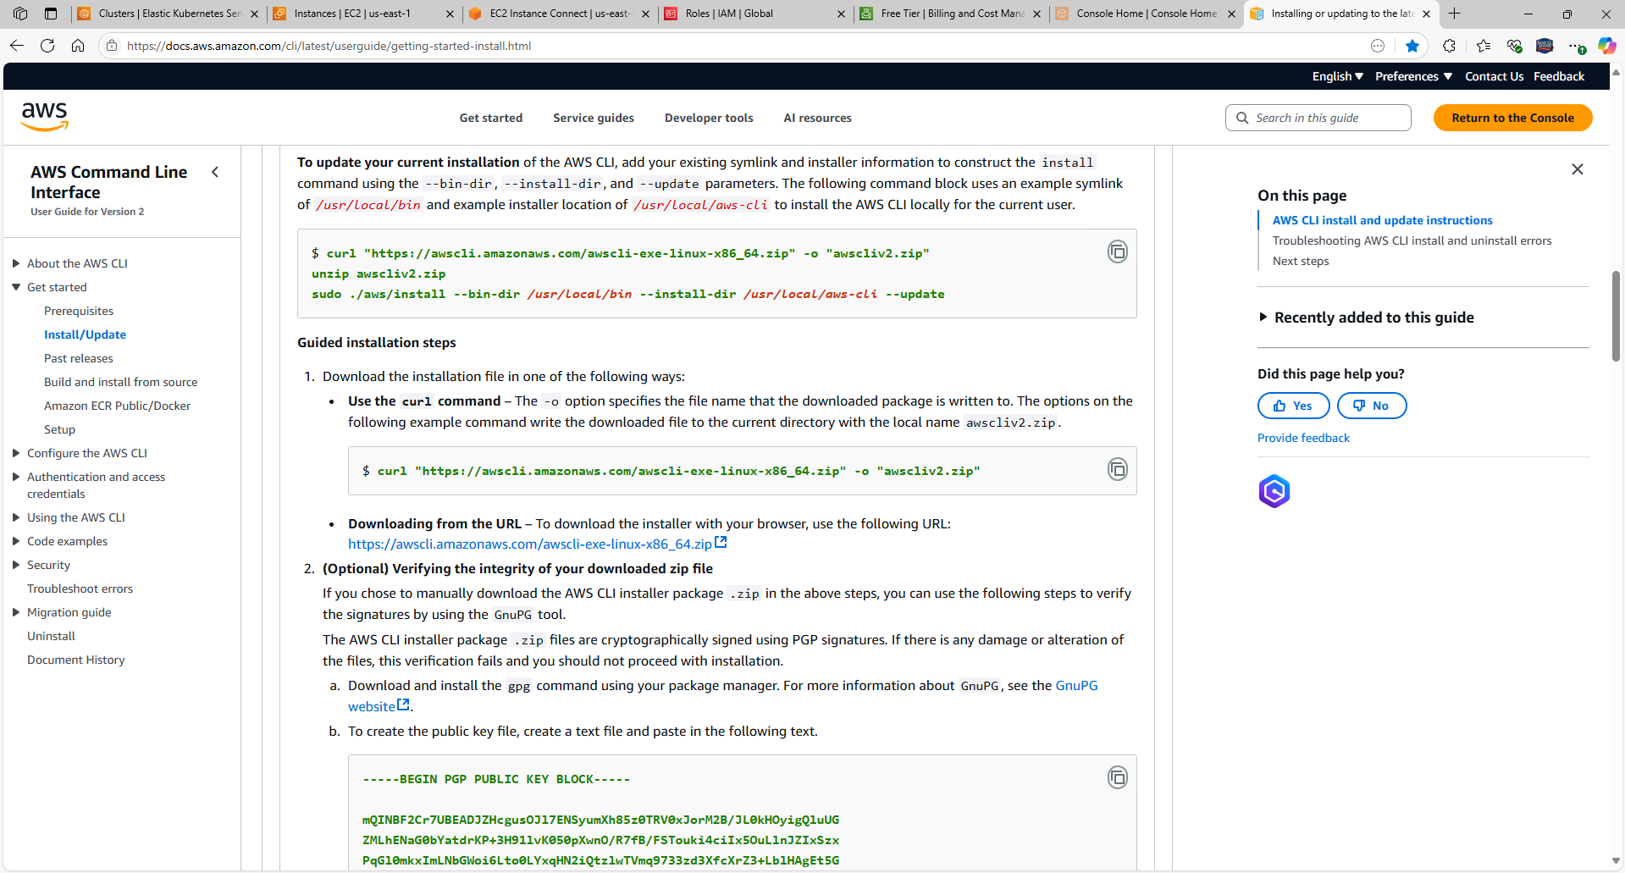

Copy and paste into Amazon Linux 2 CLI

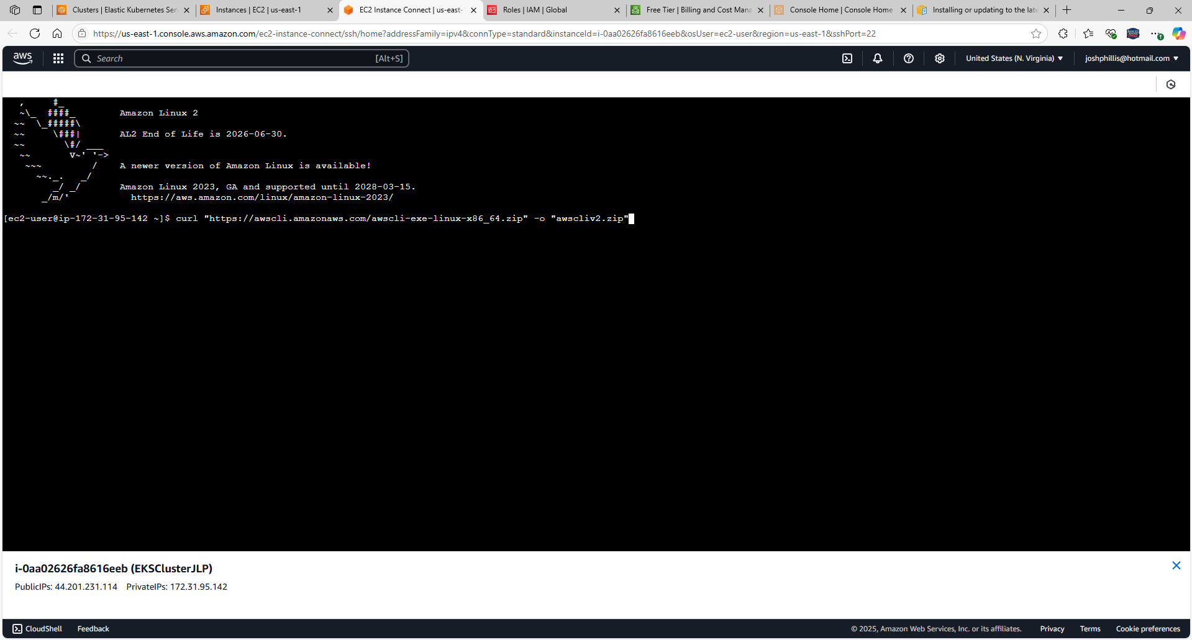

Now, unzip the zip with “unzip awscliv2.zip” command

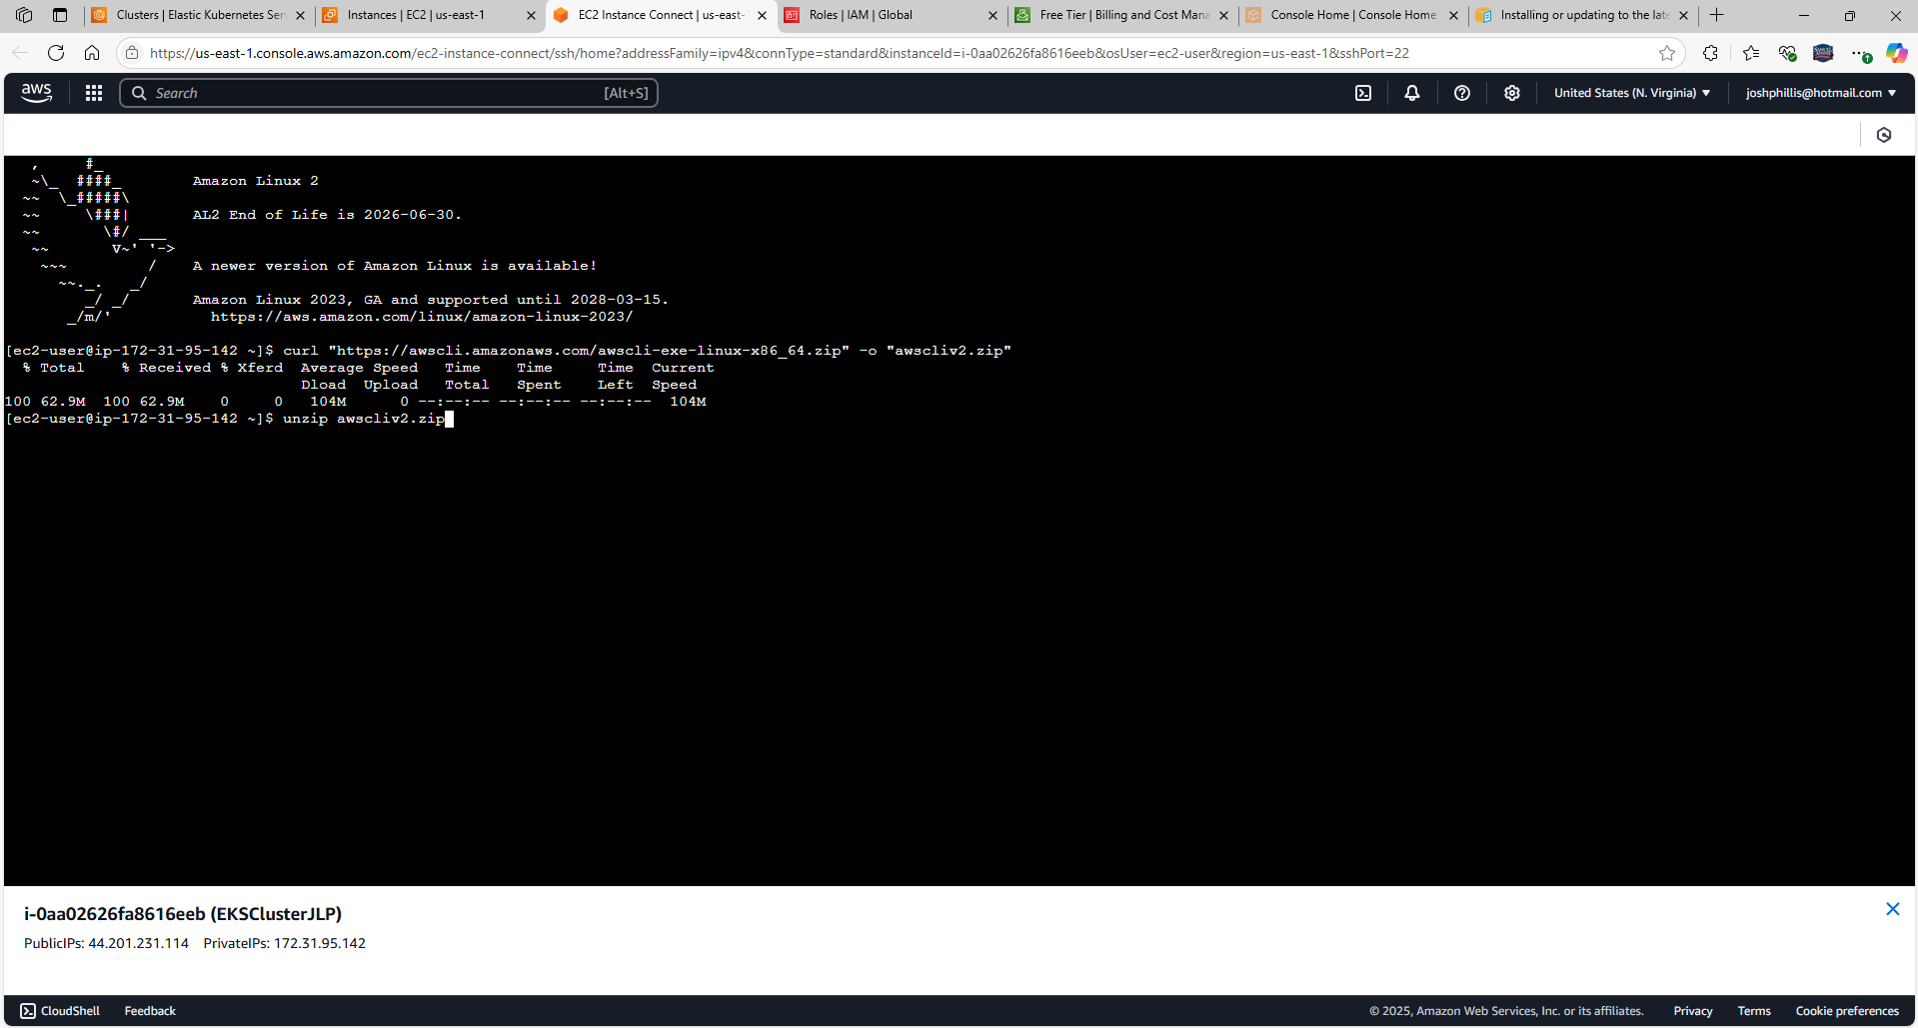

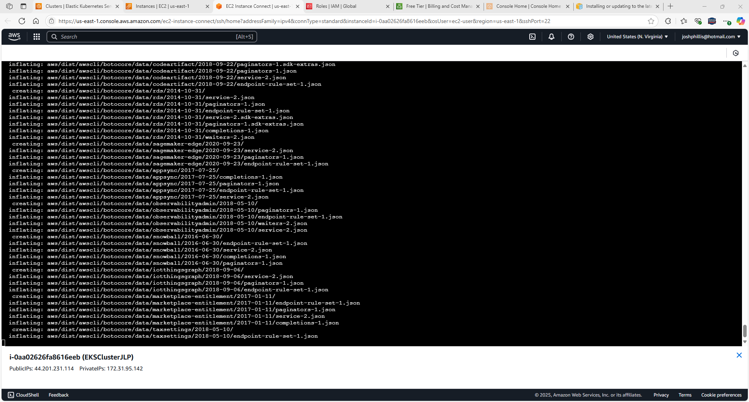

Run the install program with “sudo ./aws/install”

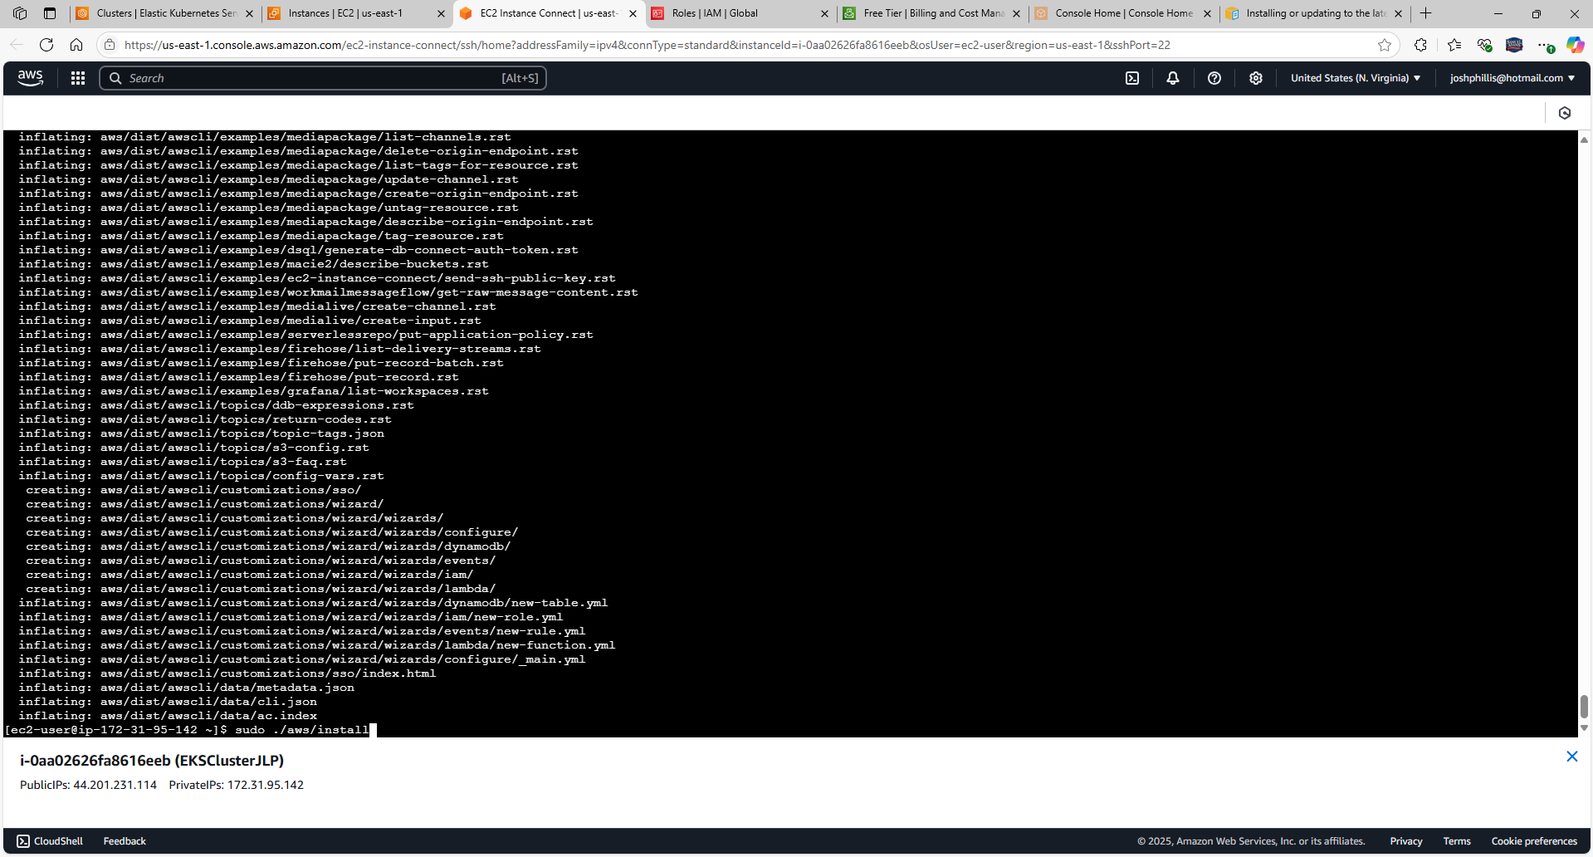

Confirm the installation with the command “aws –version”

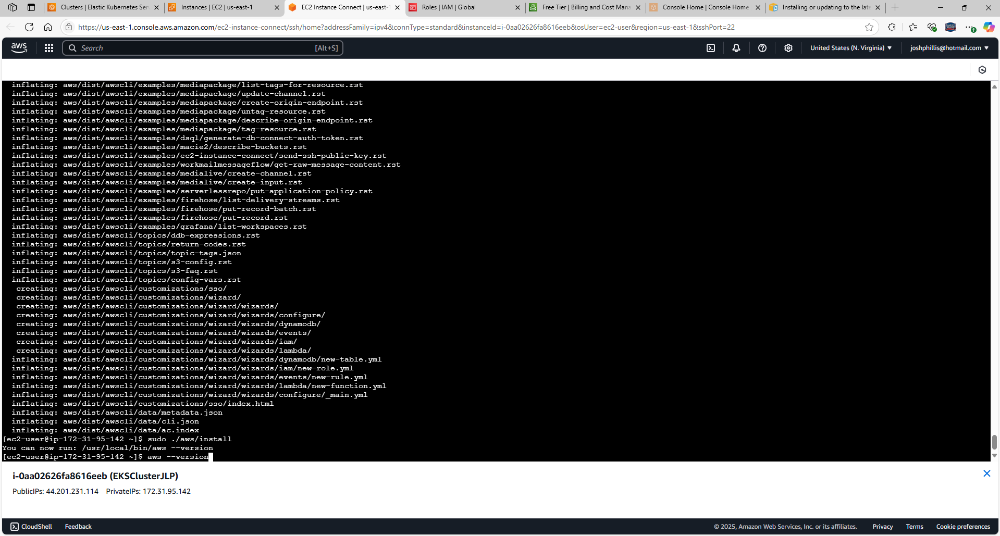

AWS CLI version output is: aws-cli/2.27.31 Python/3.13.3 Linux/5.10.237-230.948.amzn2.x86_64 exe/x86_64.amzn.2

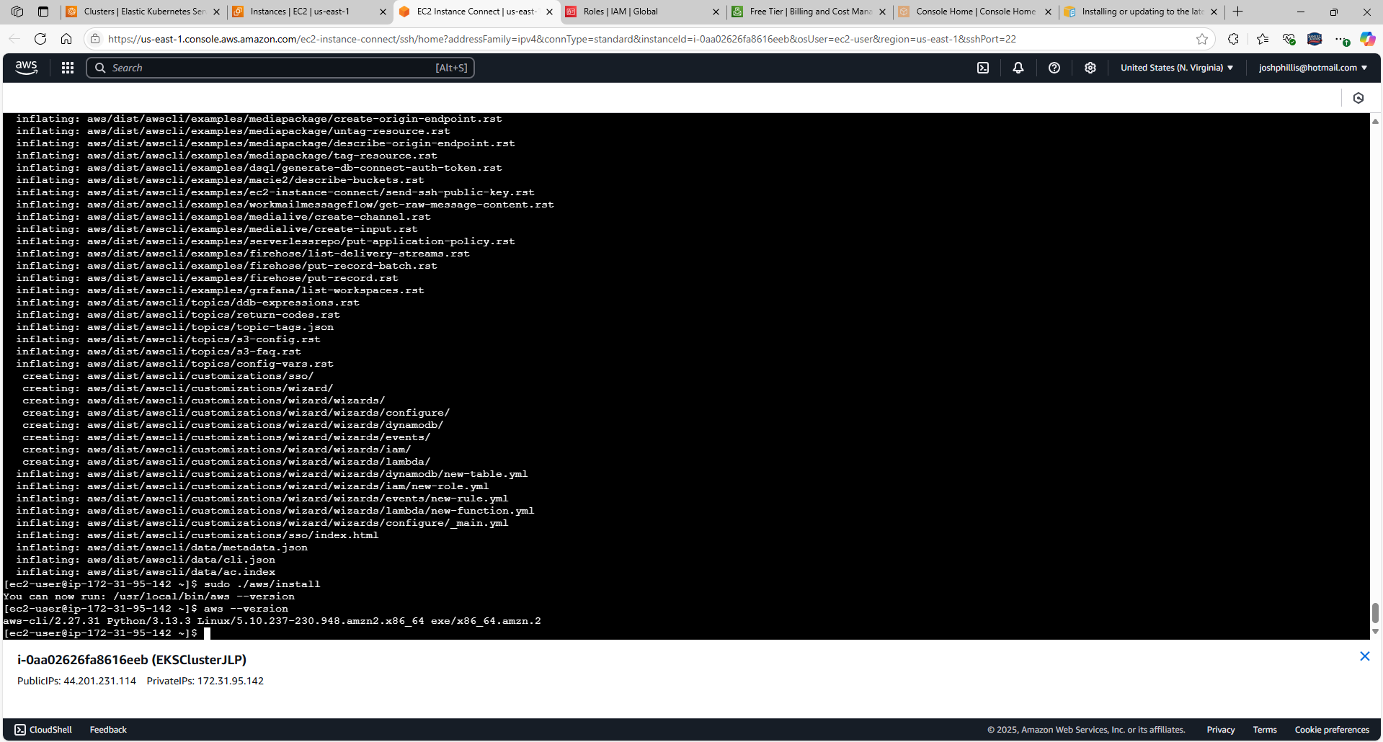

Return to IAM, select My Security Credentials

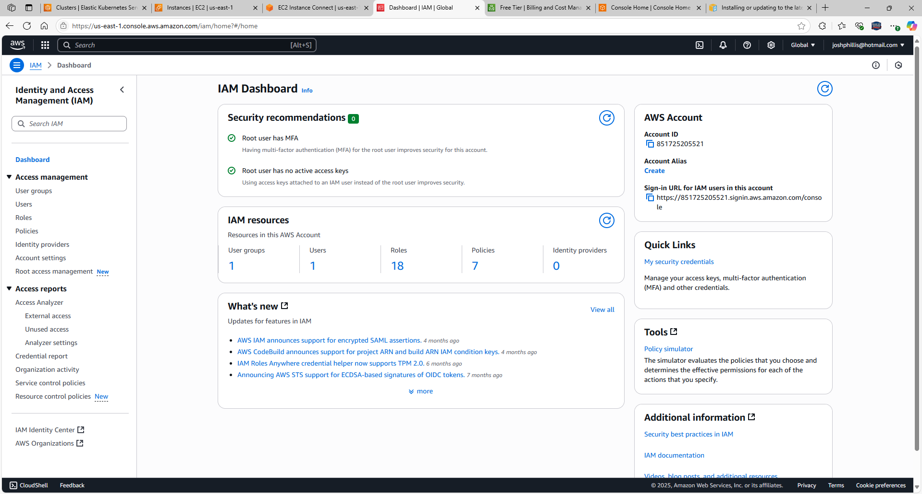

Select Create access key

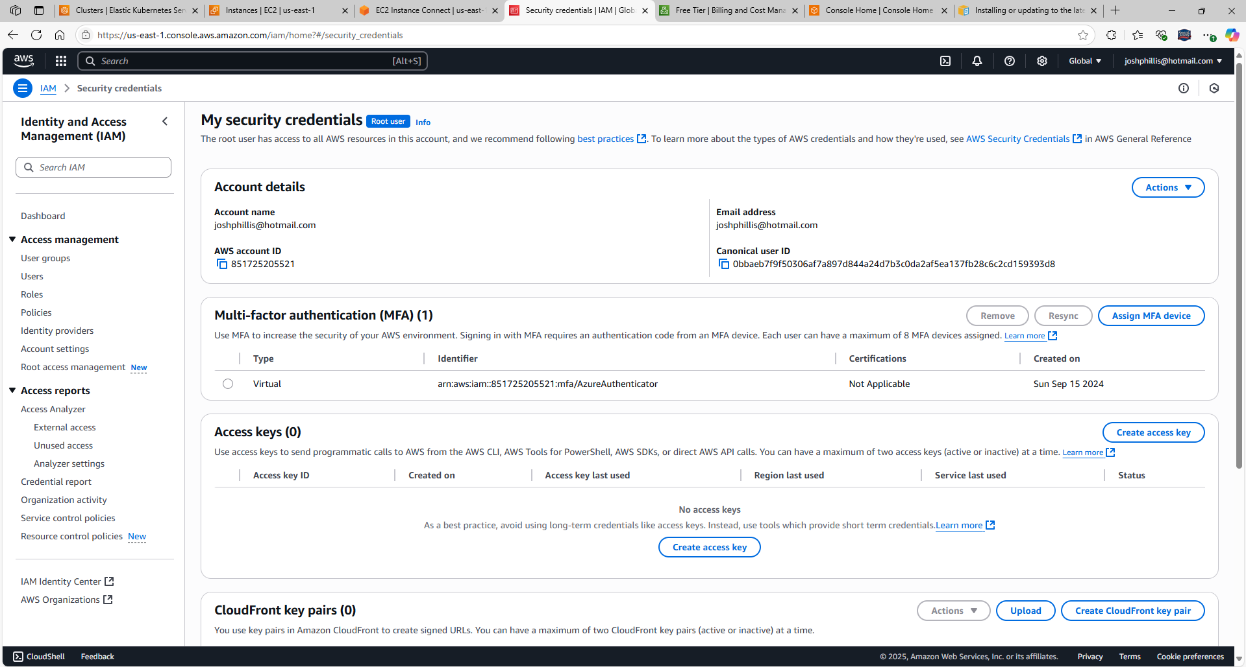

Select checkbox next to Continue to create access key

Select Create access key

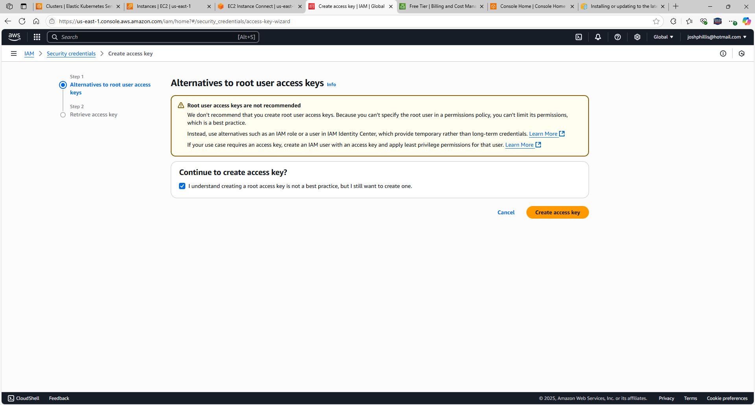

Access key created

Select Download .csv file

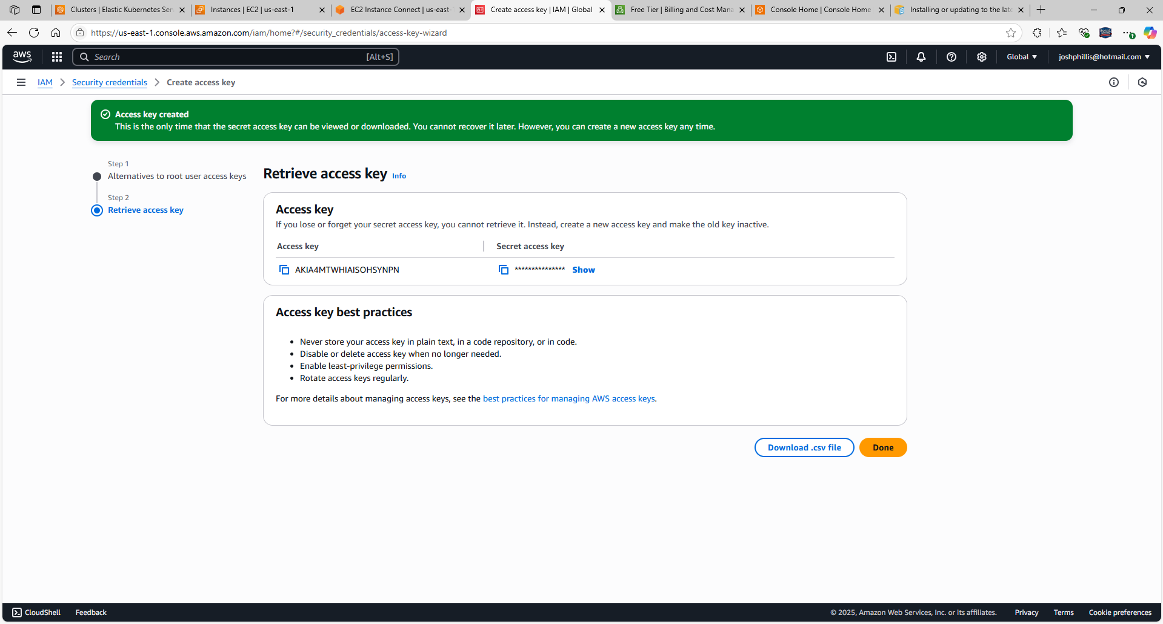

Copy and paste Access key ID:

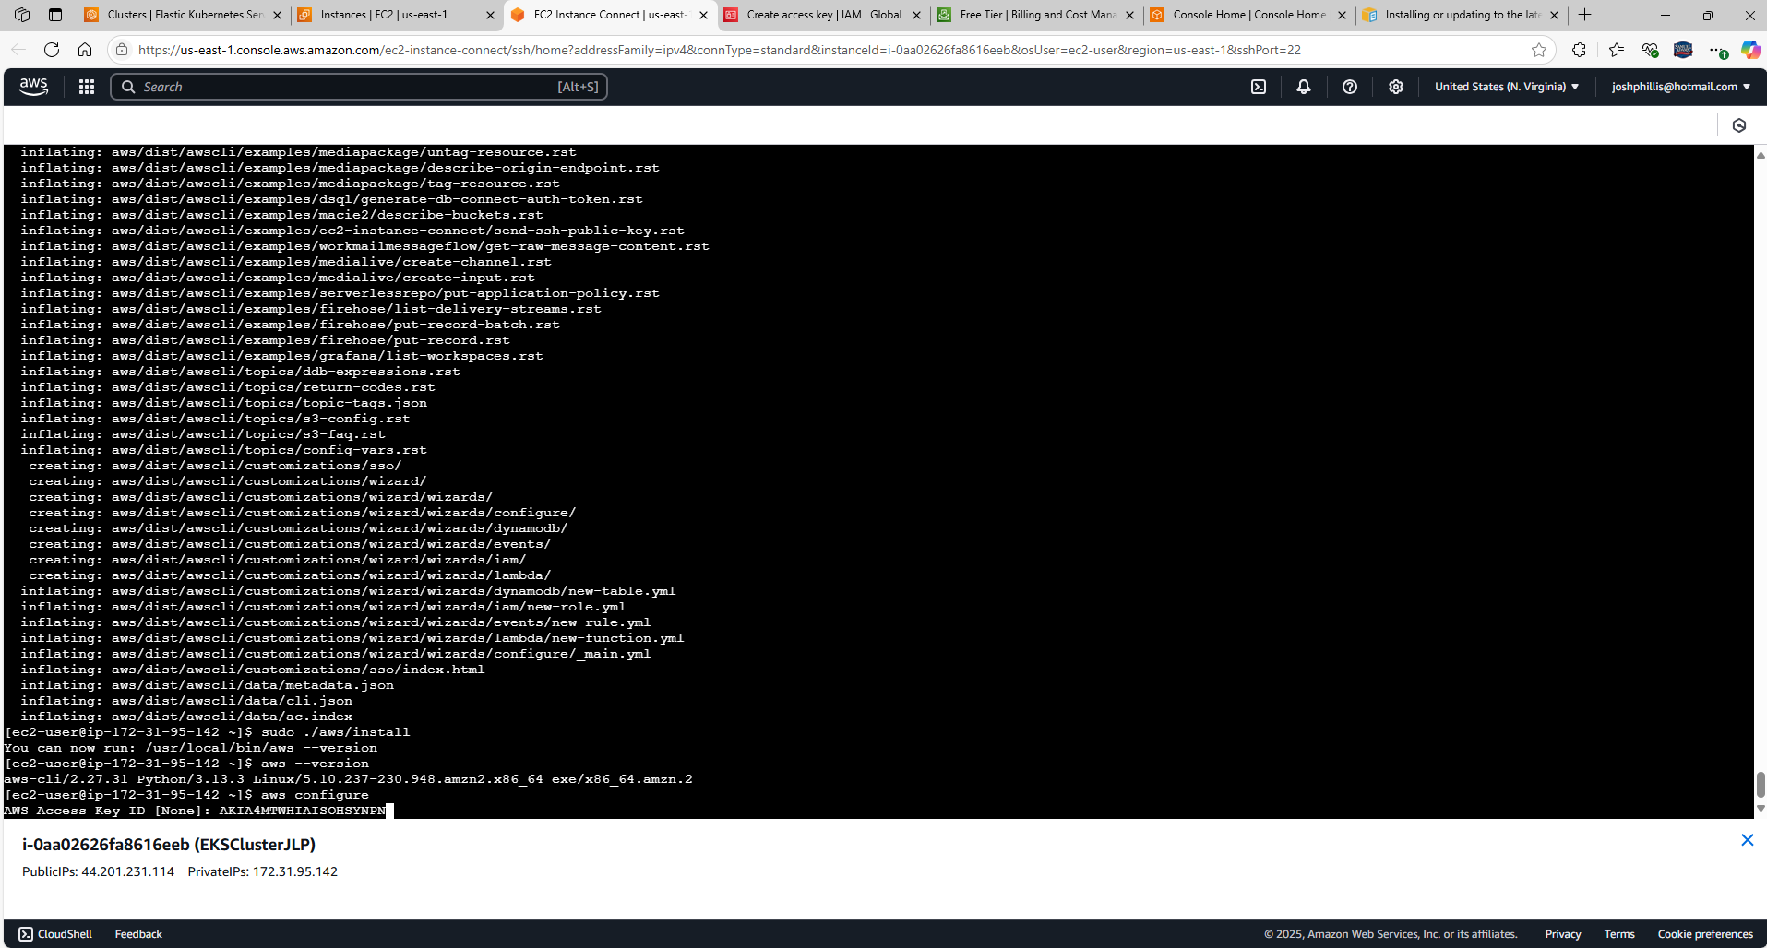

Copy and paste Secret access key:

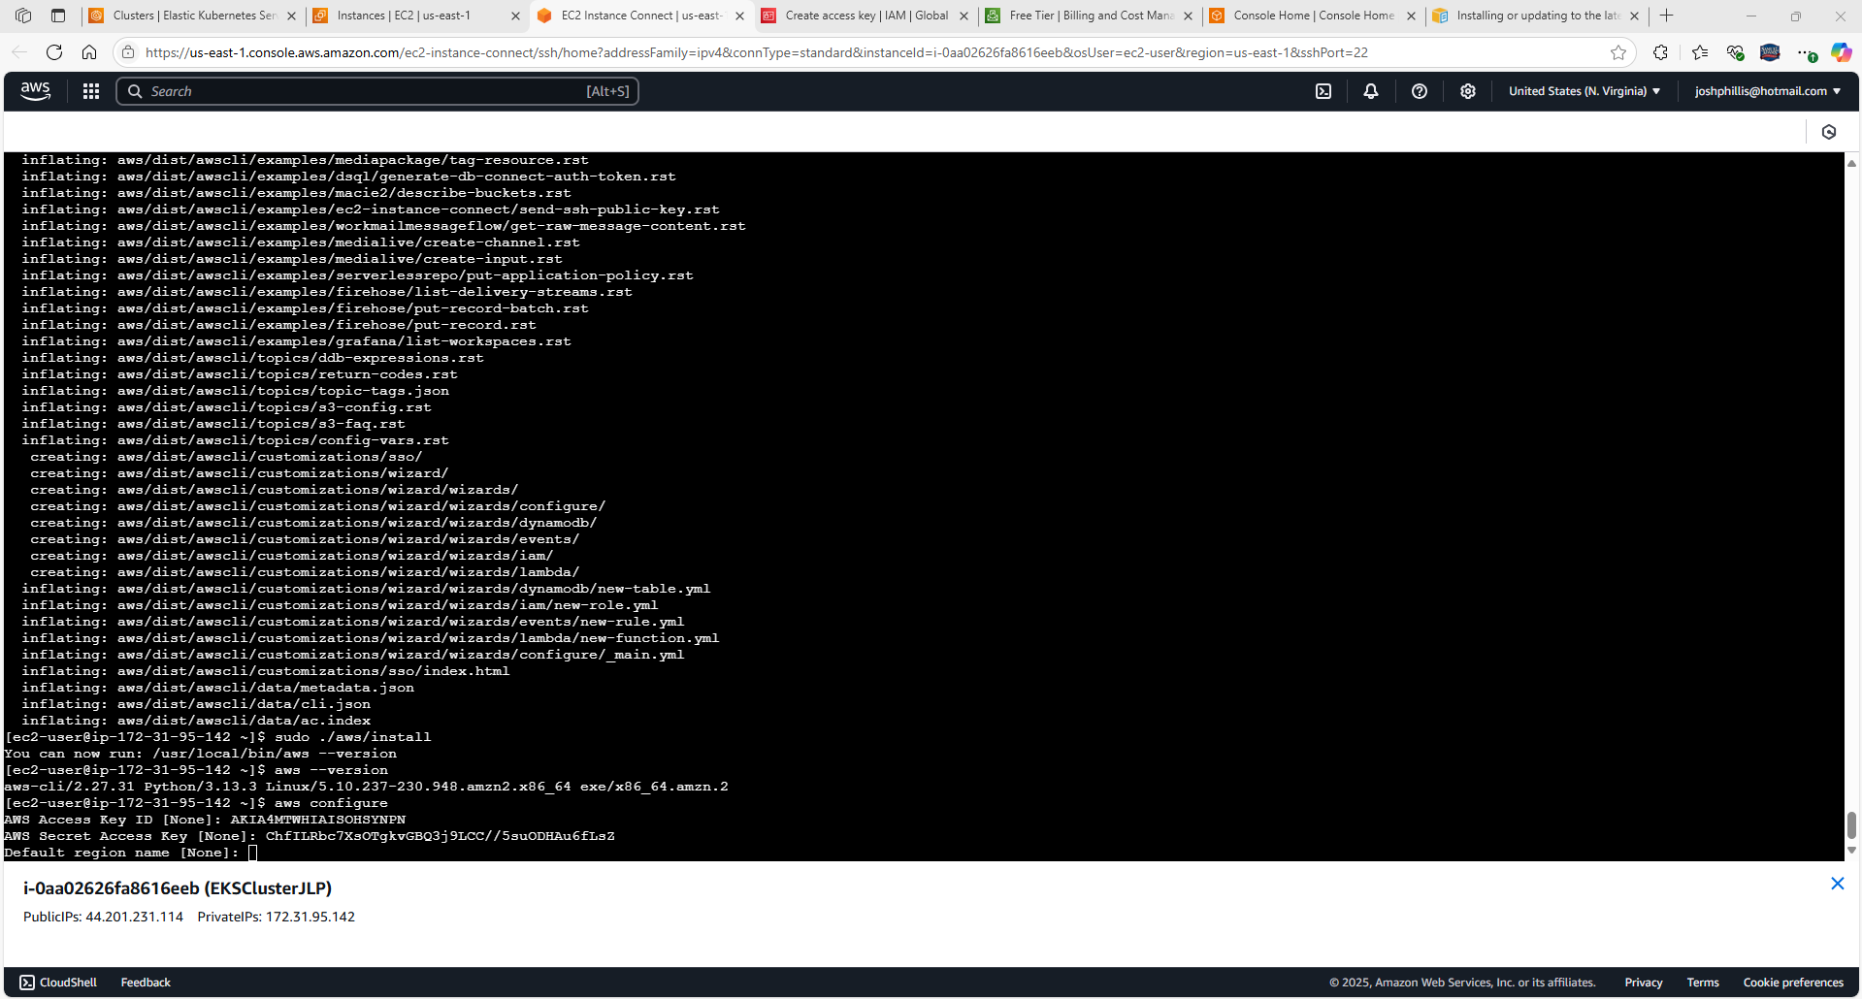

Default region name: None

Default output format: None

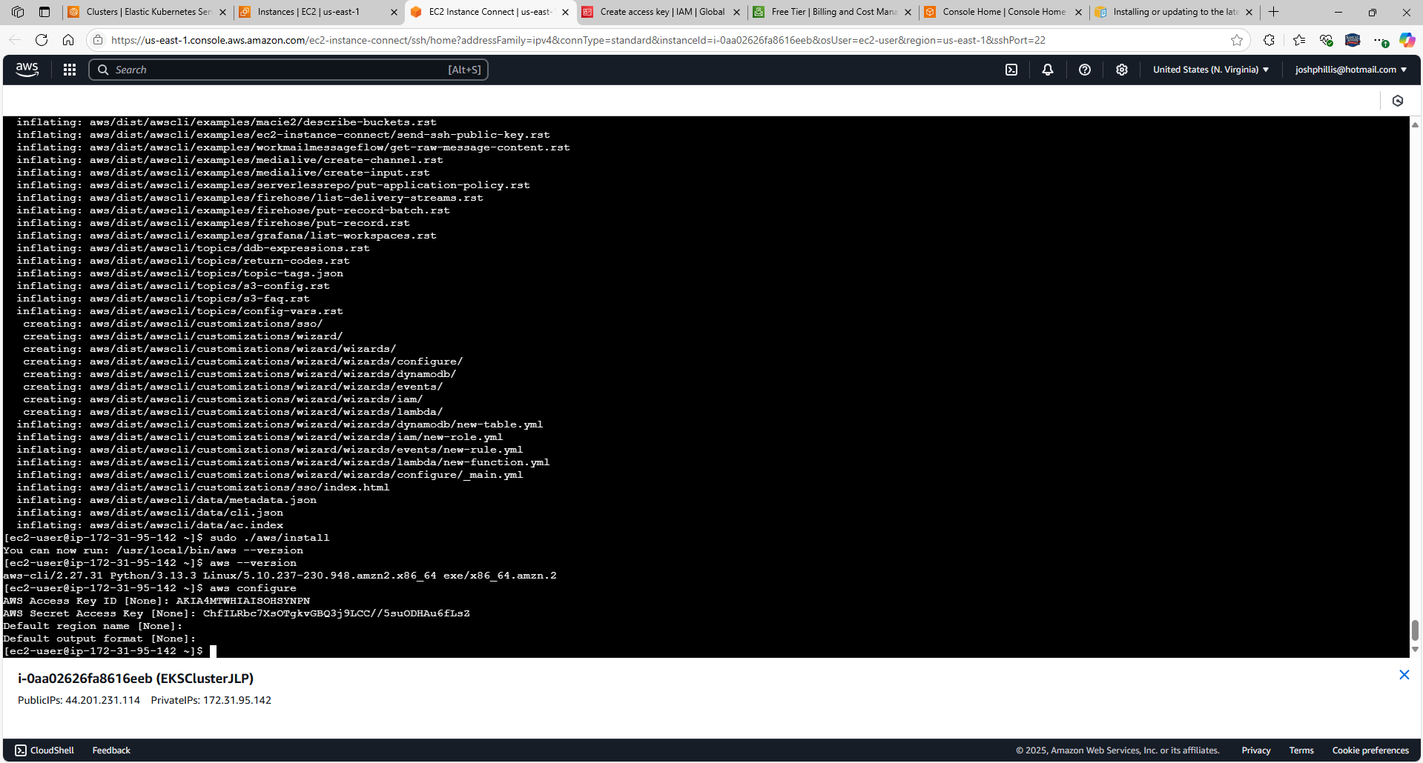

**Check to confirm EKS cluster is running:**

aws eks --region us-east-1 describe-cluster --name EKSClusterJLP --query cluster.status  
aws eks --region us-east-1 update-kubeconfig --name EKSClusterJLP

kubectl get svc

kubectl get nodes --watch

kubectl delete deployment nginx-deployment

Confirm EKS Cluster is running with “**aws eks --region us-east-1 describe-cluster --name EKSClusterJLP --query cluster.status**”

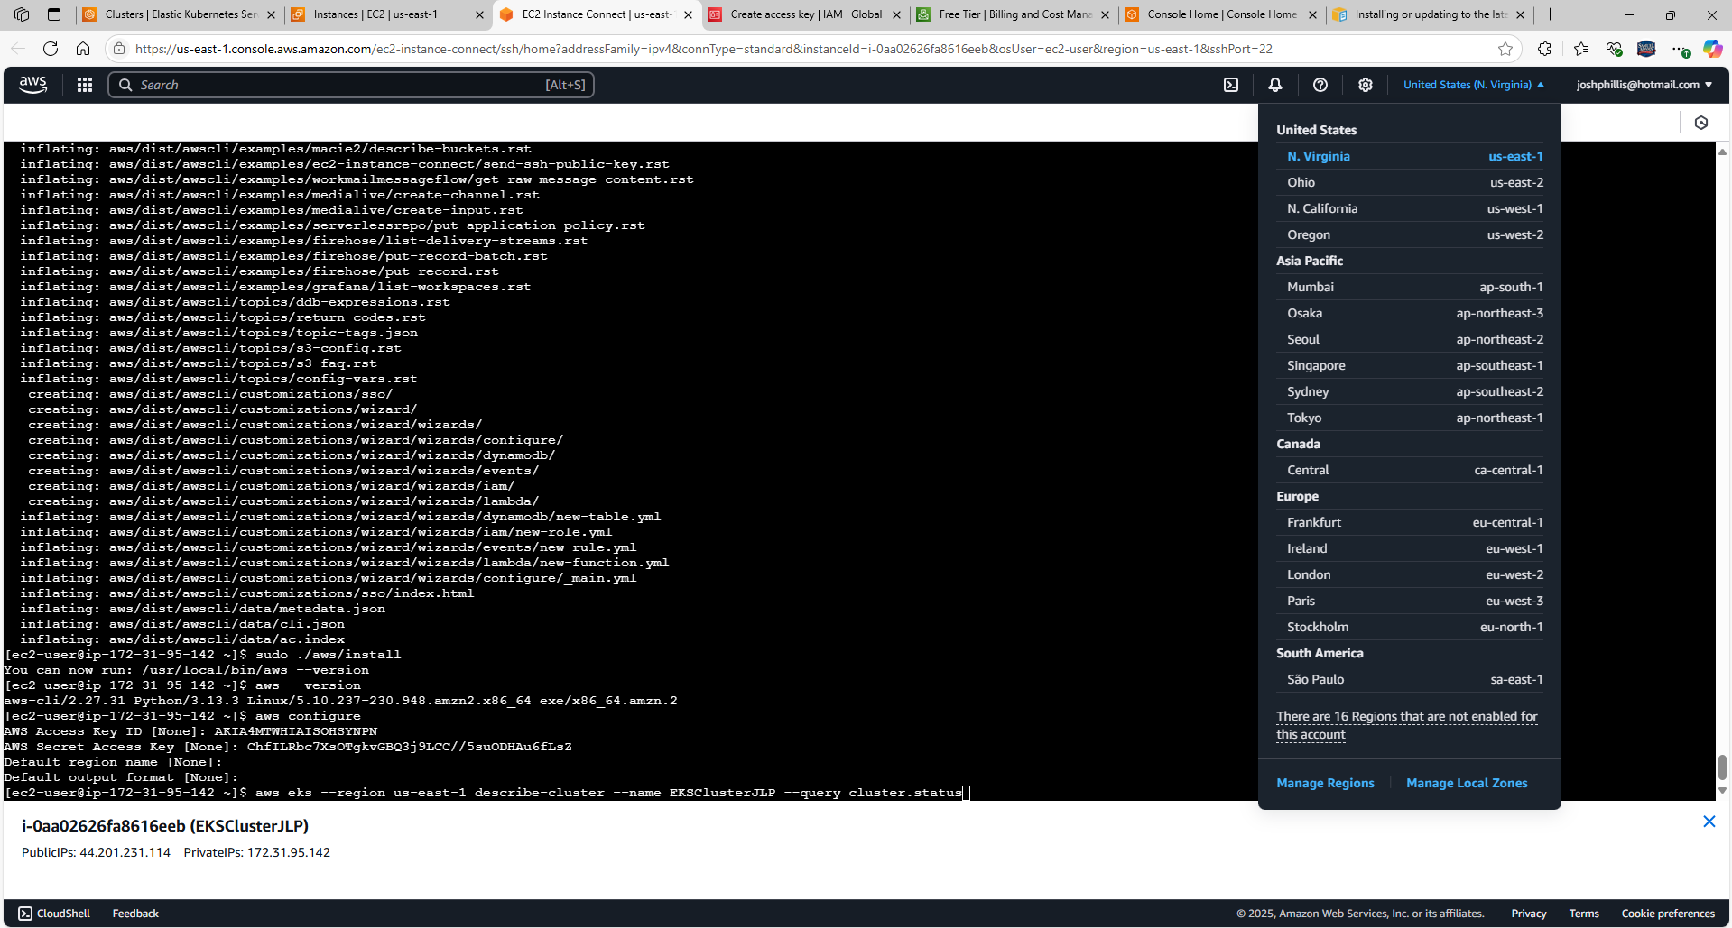

Output: Active

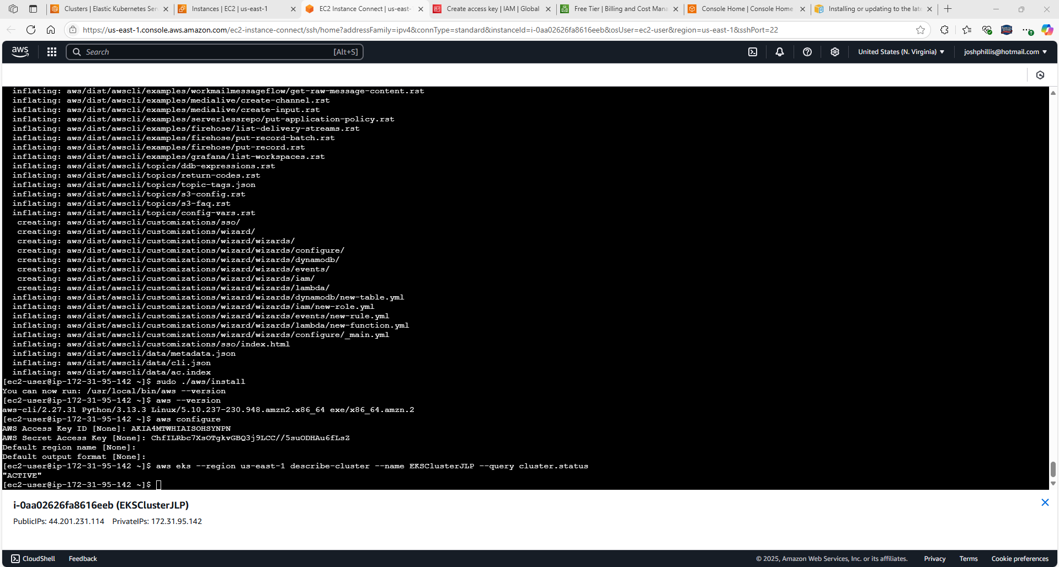

Setup instructions for kubectl located at: [Set up kubectl and eksctl - Amazon EKS](https://docs.aws.amazon.com/eks/latest/userguide/install-kubectl.html)

<https://docs.aws.amazon.com/eks/latest/userguide/install-kubectl.html>

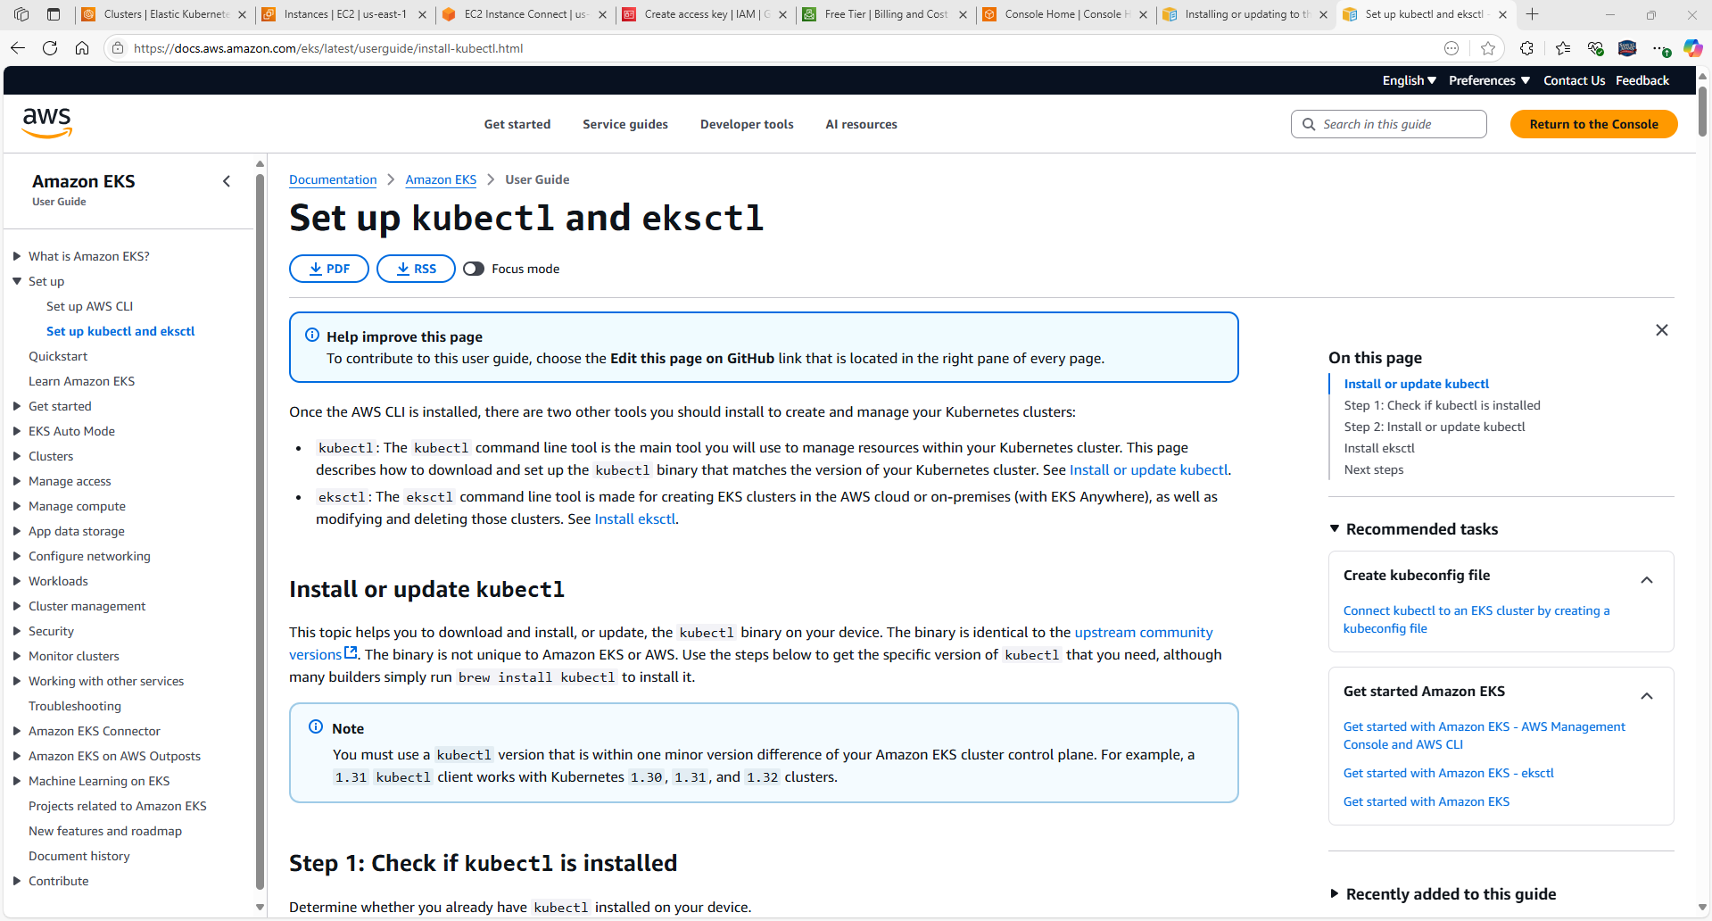

Confirm if kubectl is installed with command “kubectl version --client”

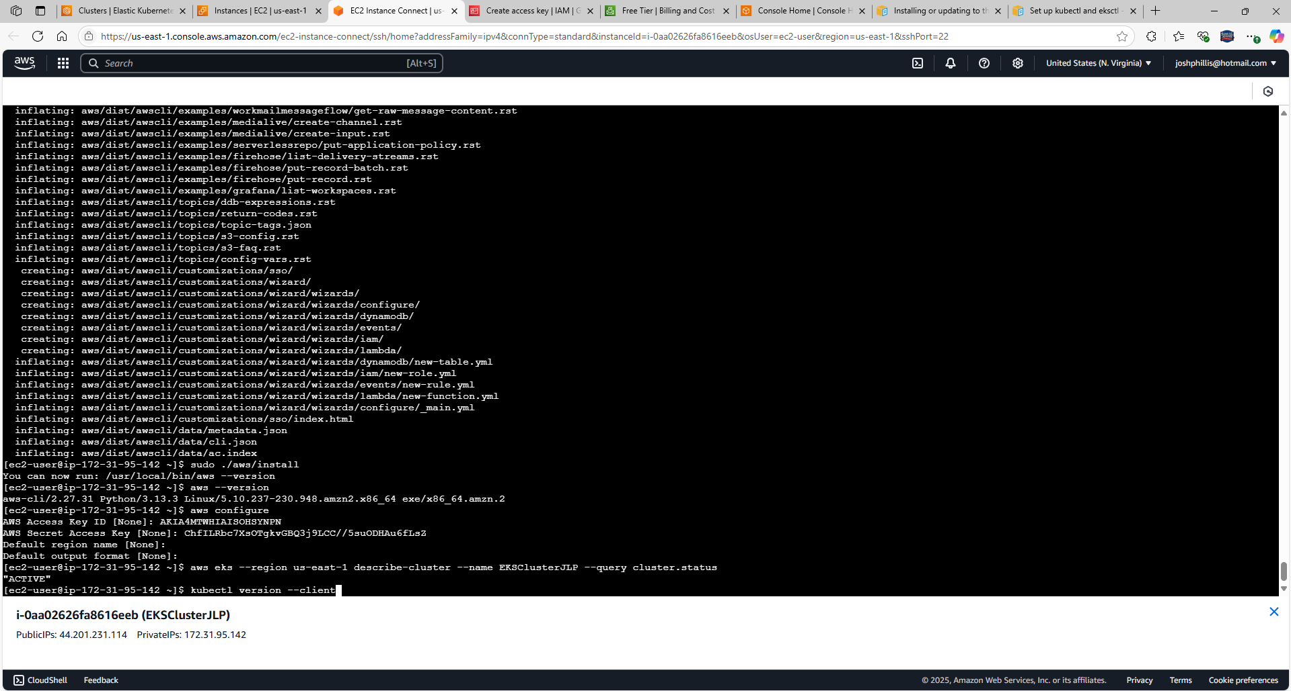

Output: -bash: kubectl: command not found

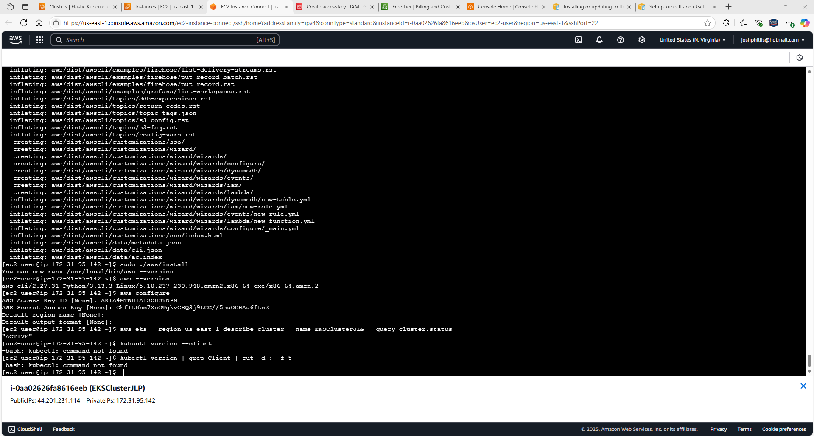

We chose an A**mazon Linux 2 AMI (HVM) – Kernel 5.10, SSD Volume Type (Free tier eligible)Linux (amd64)**, **t.2micro**

We also chose a **Kubernetes 1.33**

Command to use to install Kubectl is: **curl -O https://s3.us-west-2.amazonaws.com/amazon-eks/1.33.0/2025-05-01/bin/linux/amd64/kubectl**

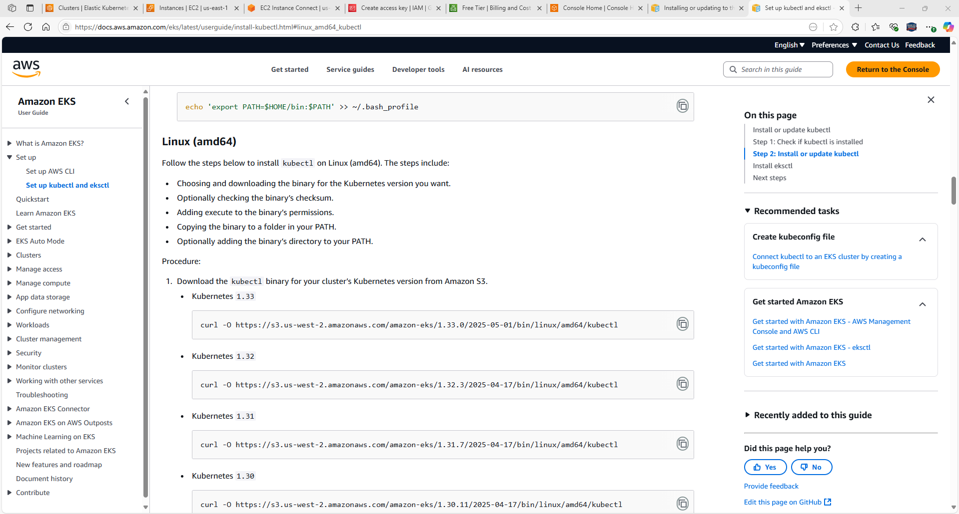

Copy and paste command: **curl -O https://s3.us-west-2.amazonaws.com/amazon-eks/1.33.0/2025-05-01/bin/linux/amd64/kubectl**

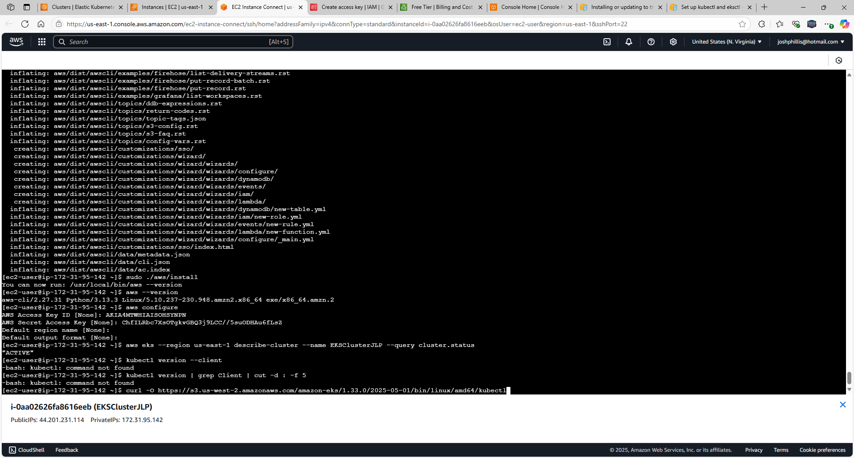

kubectl is downloaded

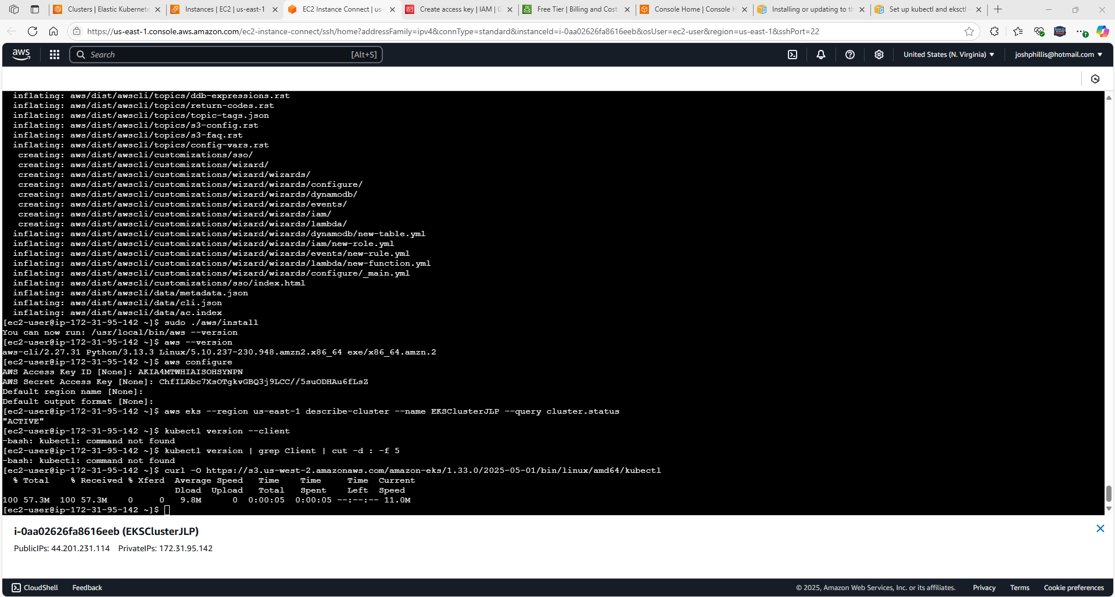

Provide the access / permission with command: **chmod +x ./kubectl**

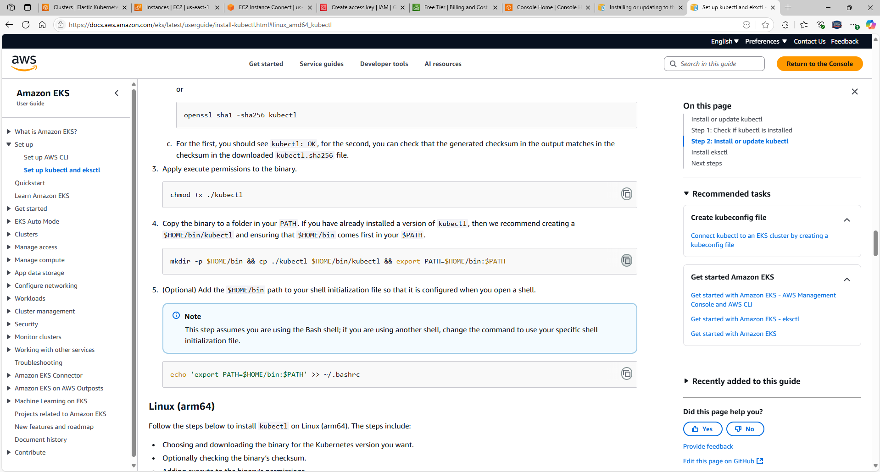

Copy / paste: **chmod +x ./kubectl**

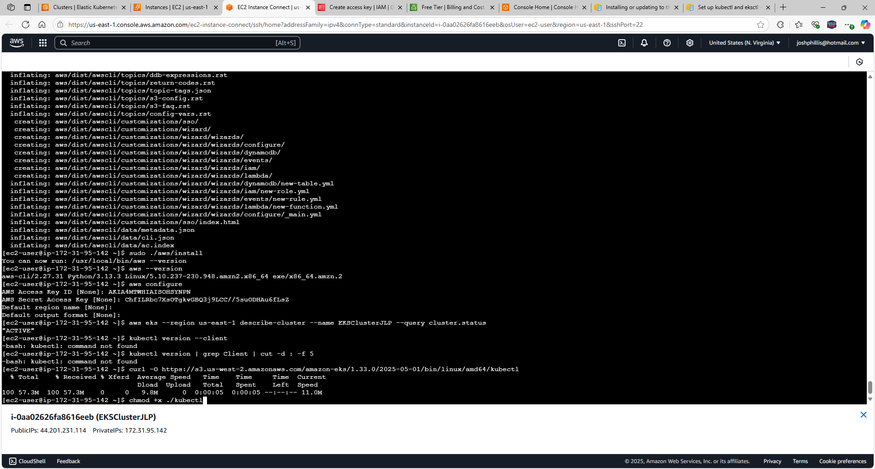

Provide the binary to a folder in your PATH with: **mkdir -p $HOME/bin && cp ./kubectl $HOME/bin/kubectl && export PATH=$HOME/bin:$PATH**

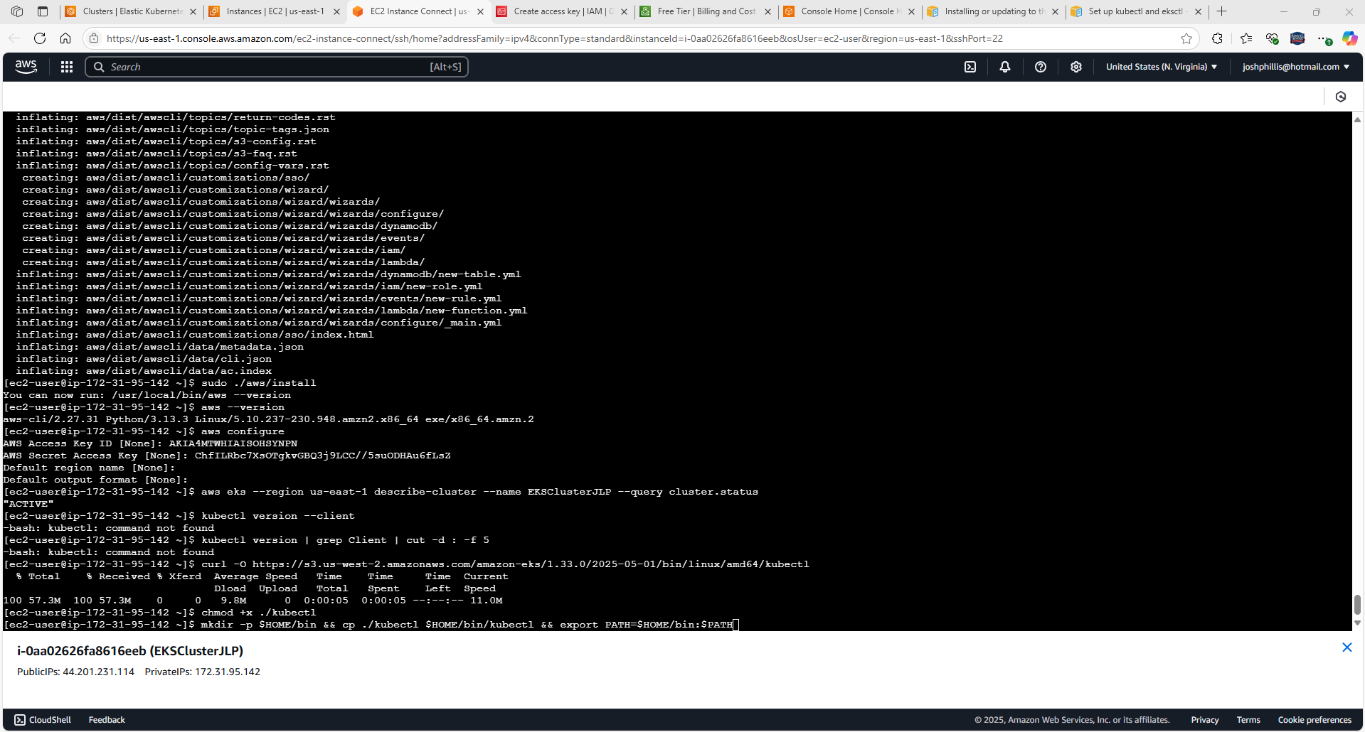

Add the $HOME/bin with command: **echo 'export PATH=$HOME/bin:$PATH' >> ~/.bashrc**

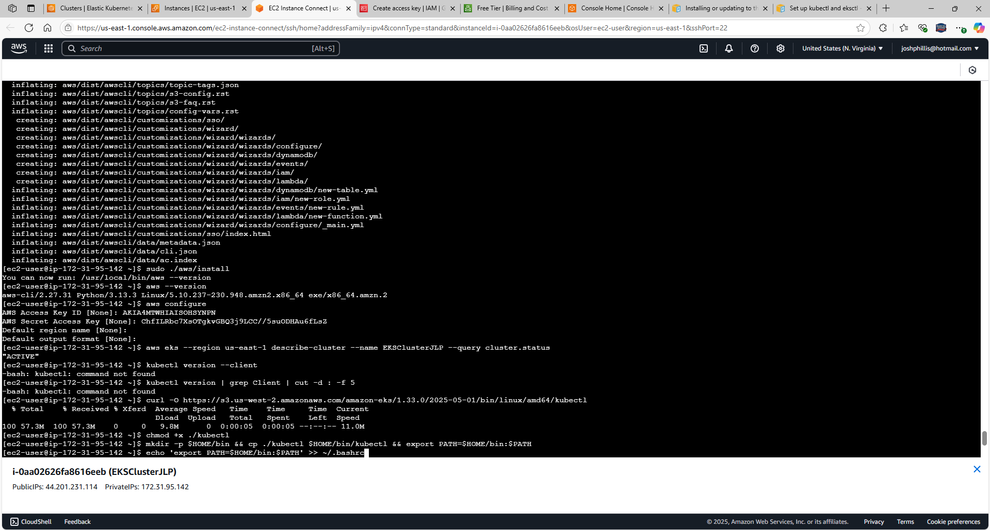

Verify the version after kubectl was installed with command: **kubectl version -short --client**

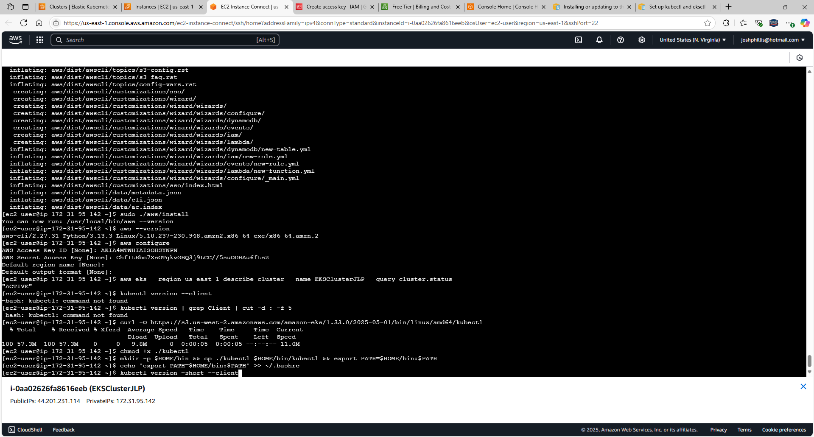

Output: Client Version: v1.33.0-eks-802817d

Kustomize Version: v5.6.0

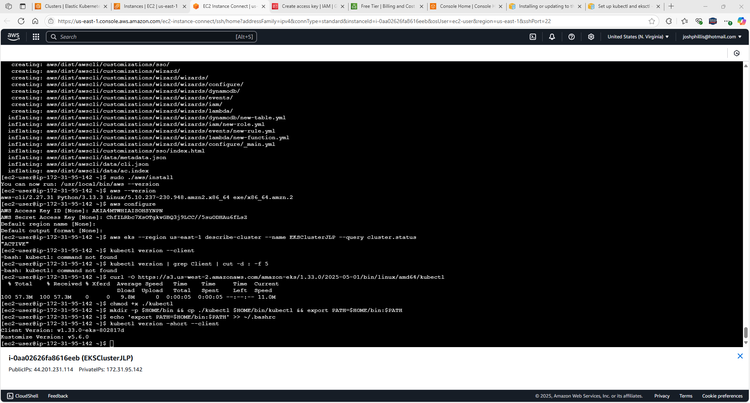

To configure local kubectl tool to communicate with an Amazon EKS cluster, enter command: **aws eks --region us-east-1 update-kubeconfig --name EKSClusterJLP**

Output: **Added new context arn:aws:eks:us-east-1:851725205521:cluster/EKSClusterJLP to /home/ec2-user/.kube/config**

**Settings are complete.**

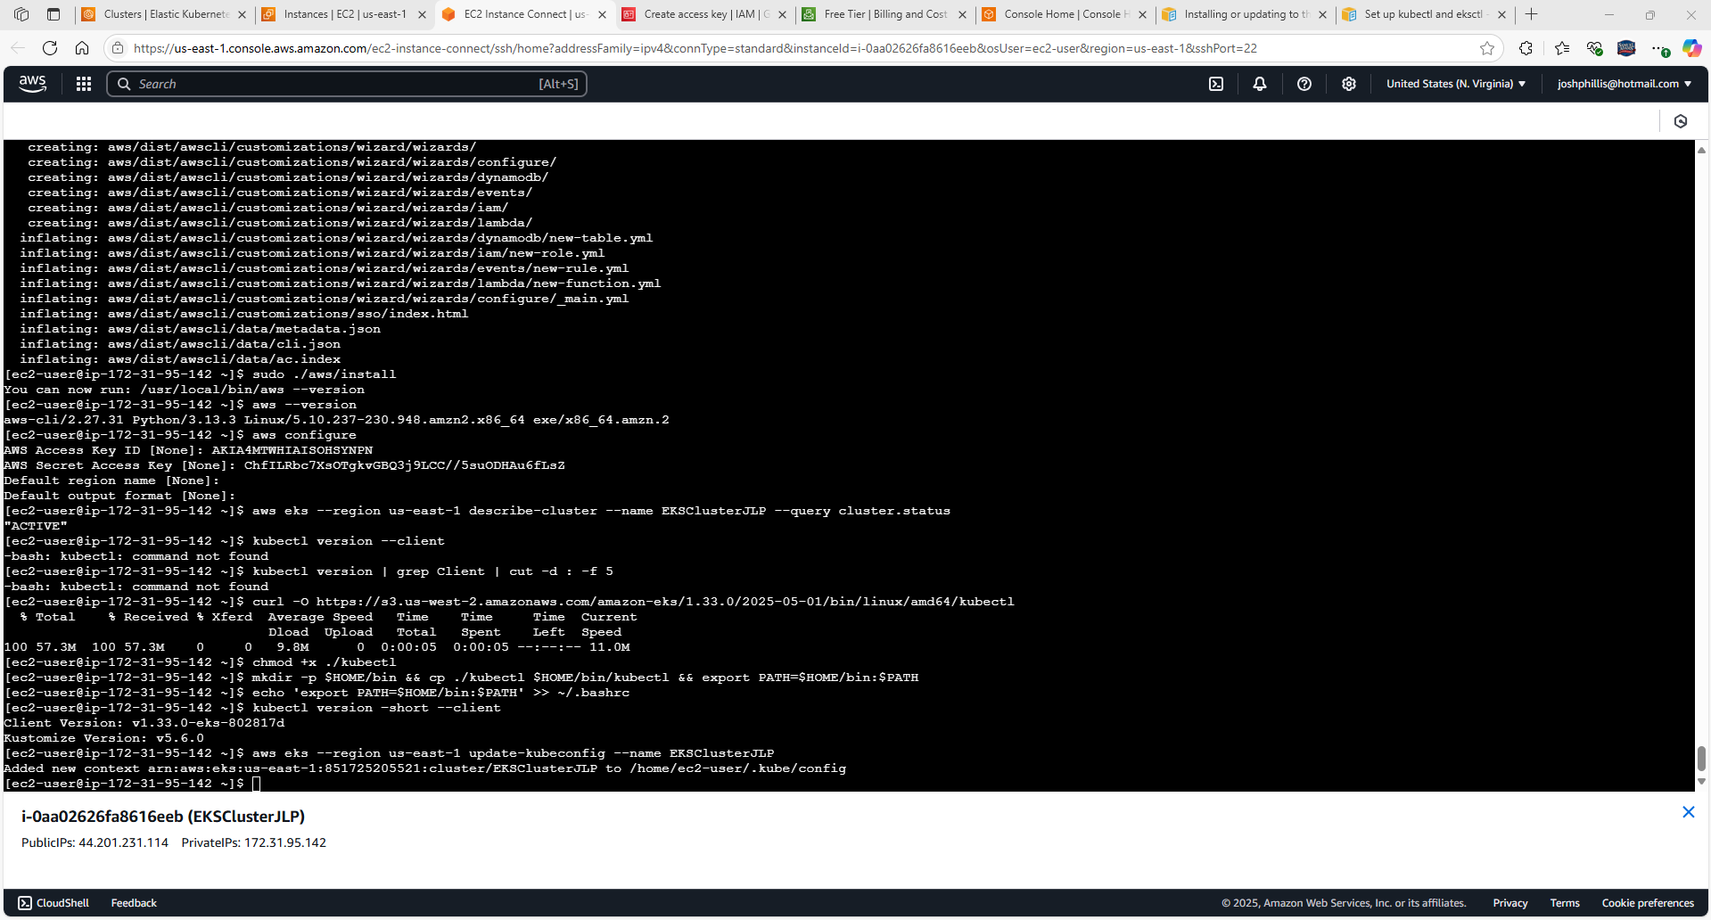

Return to EKSClusterJLP

Select EKSClusterJLP

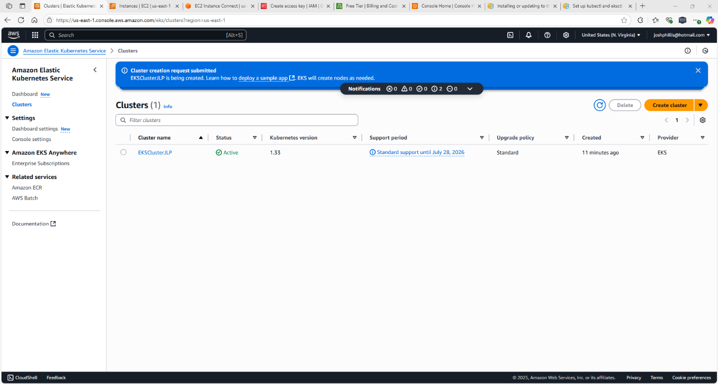  
Select **Compute** tab

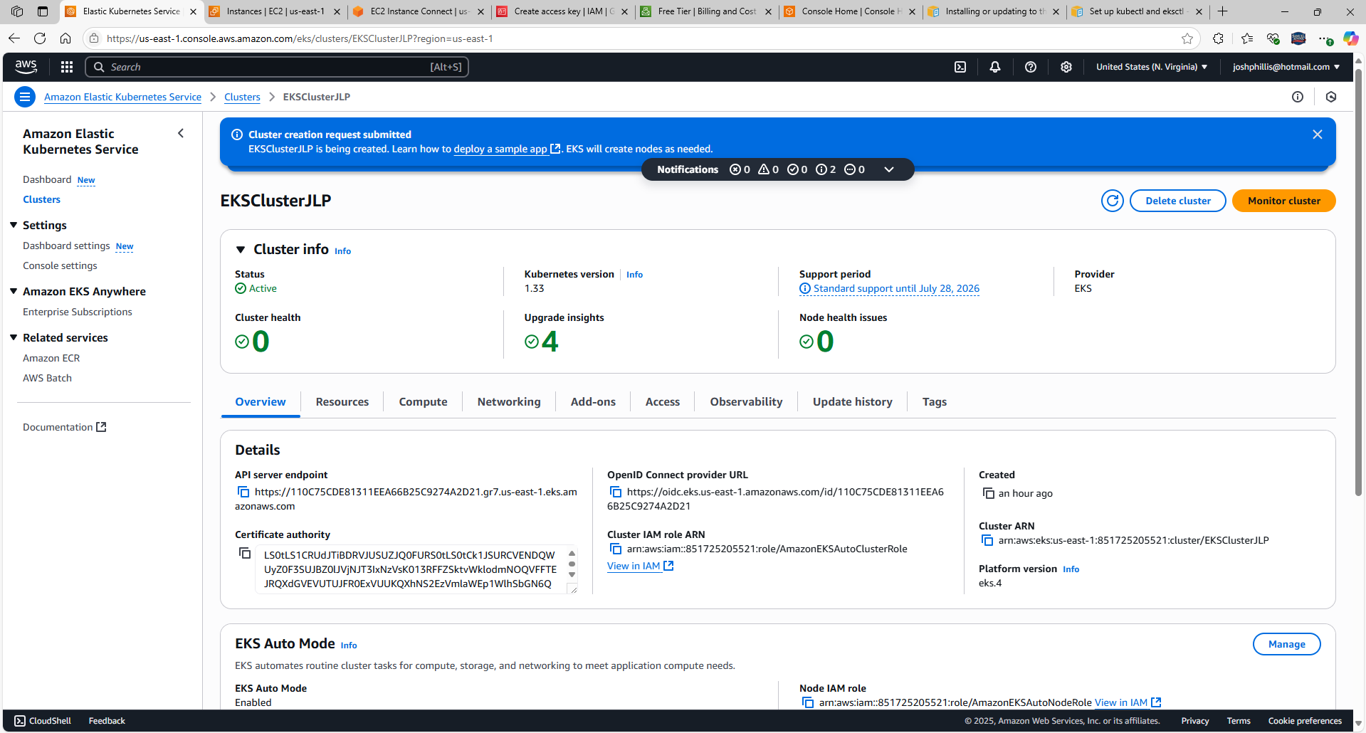

Scroll down, select Add node group

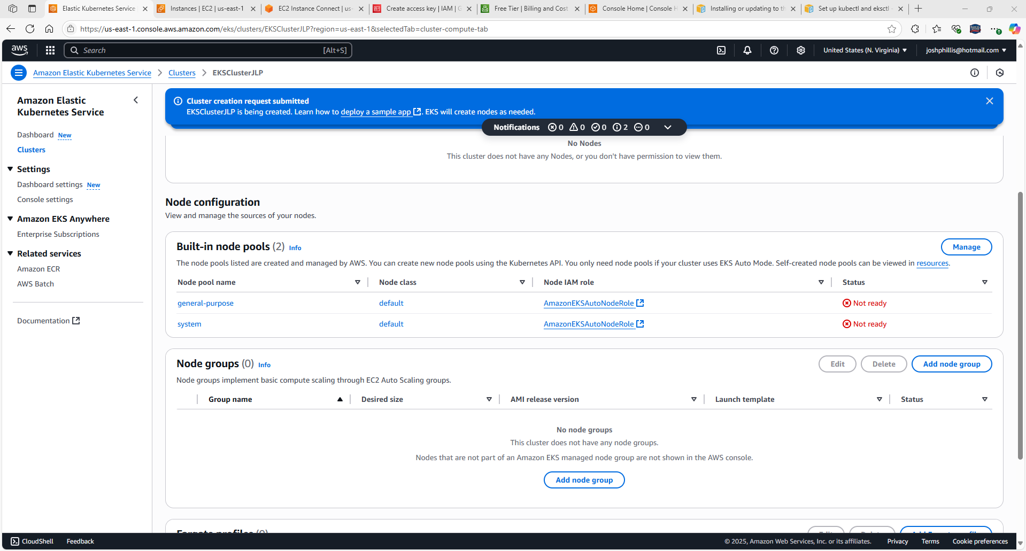

Configure node group, name **myworkernodeJLP**

Node IAM role: **AmazonEKSAutoNodeRole** (created previously)

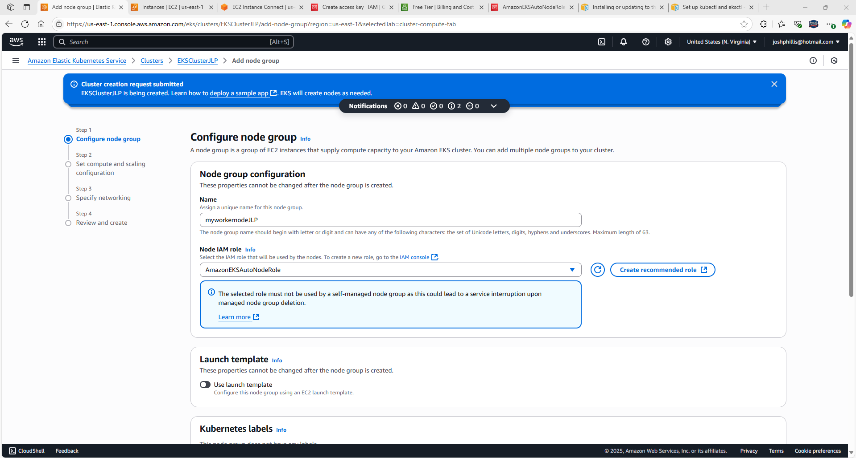

Returned to IAM Management

Confirmed Node IAM role AmazonEKSAutoNodeRole has the EC2 permission policies required:

AmazonEC2ContainerRegistryReadOnly

AmazonEKS_CNI_Policy

AmazonEKSWorkerNodePolicy

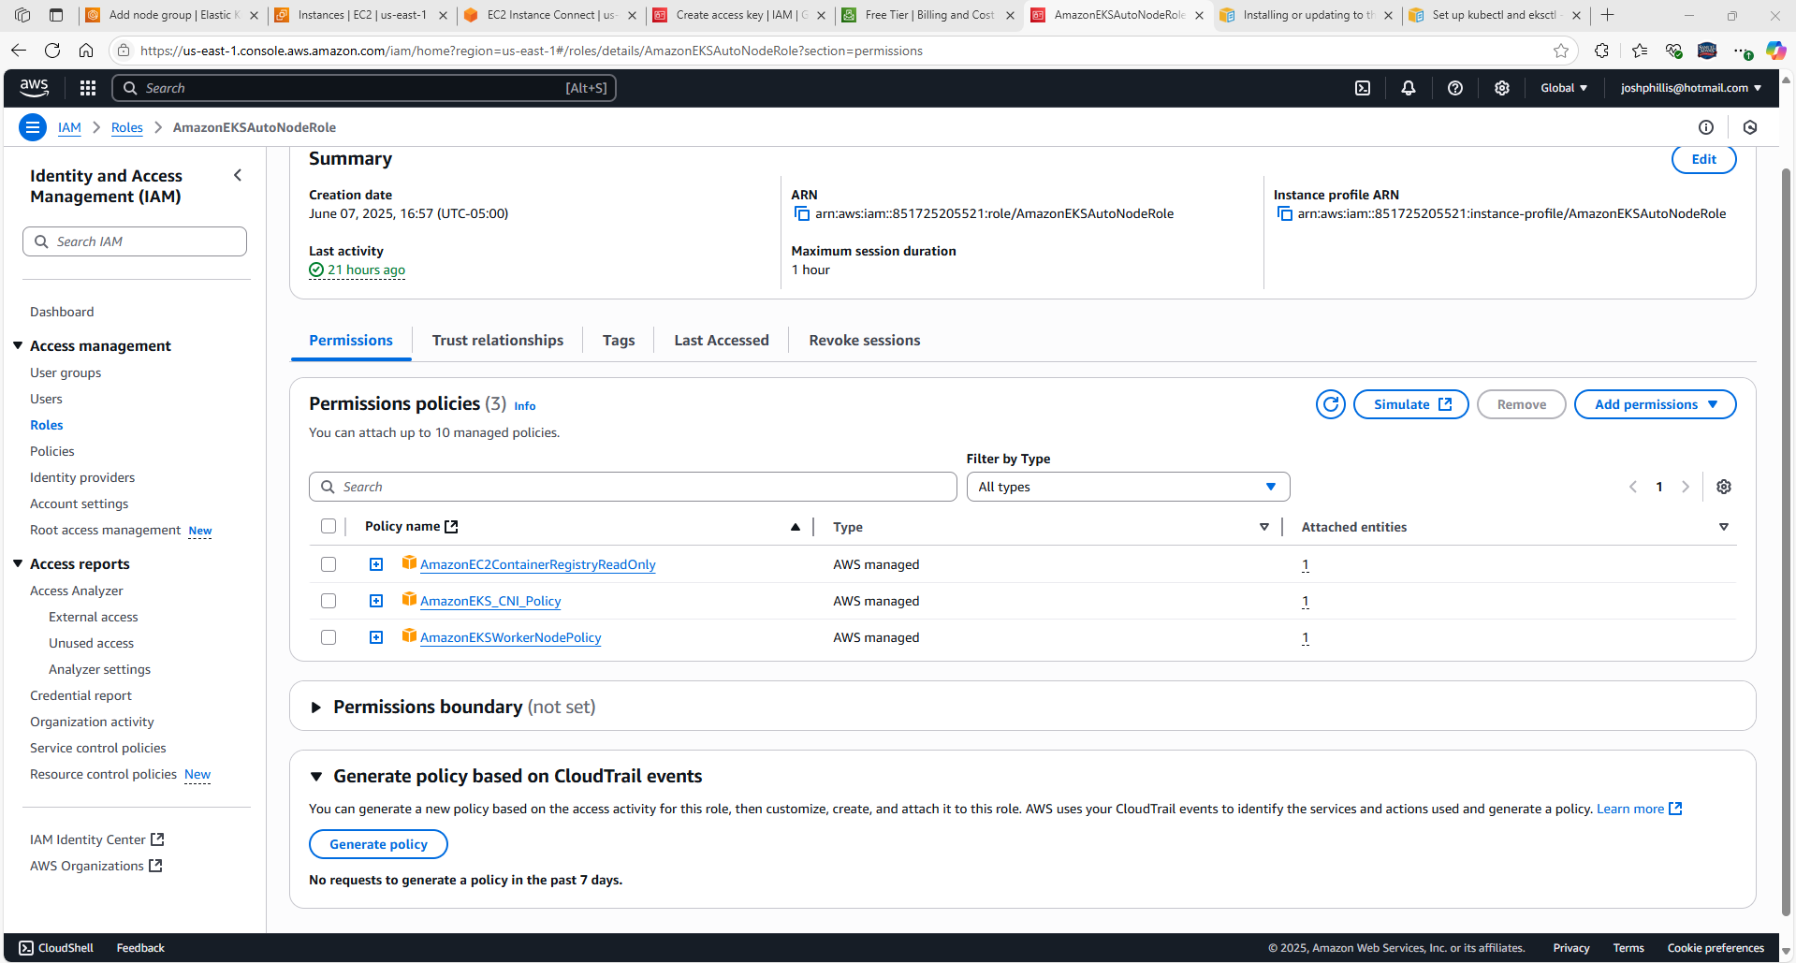

Scroll down, select Next

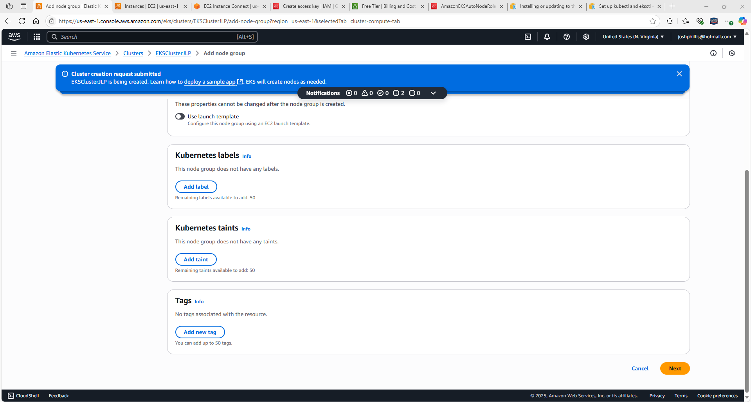

Adjusted Disk size from 20 to 5

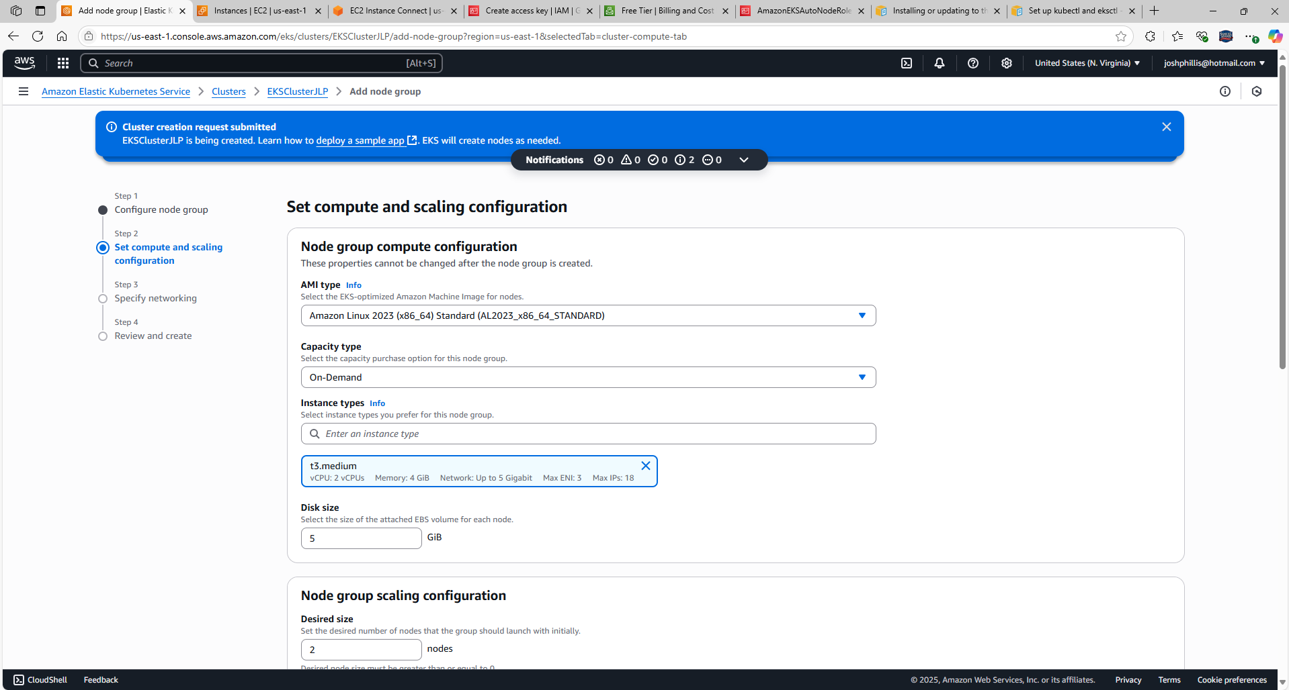

Scroll down, select Next

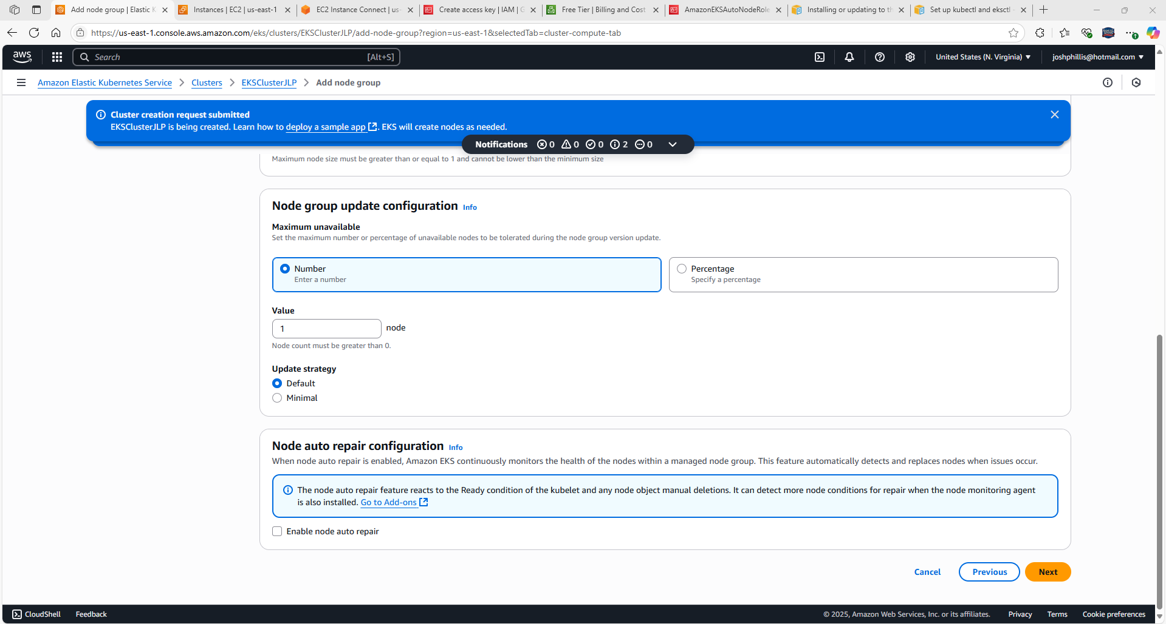

All 3 subnets are listed

Select “Configure remote access to nodes”

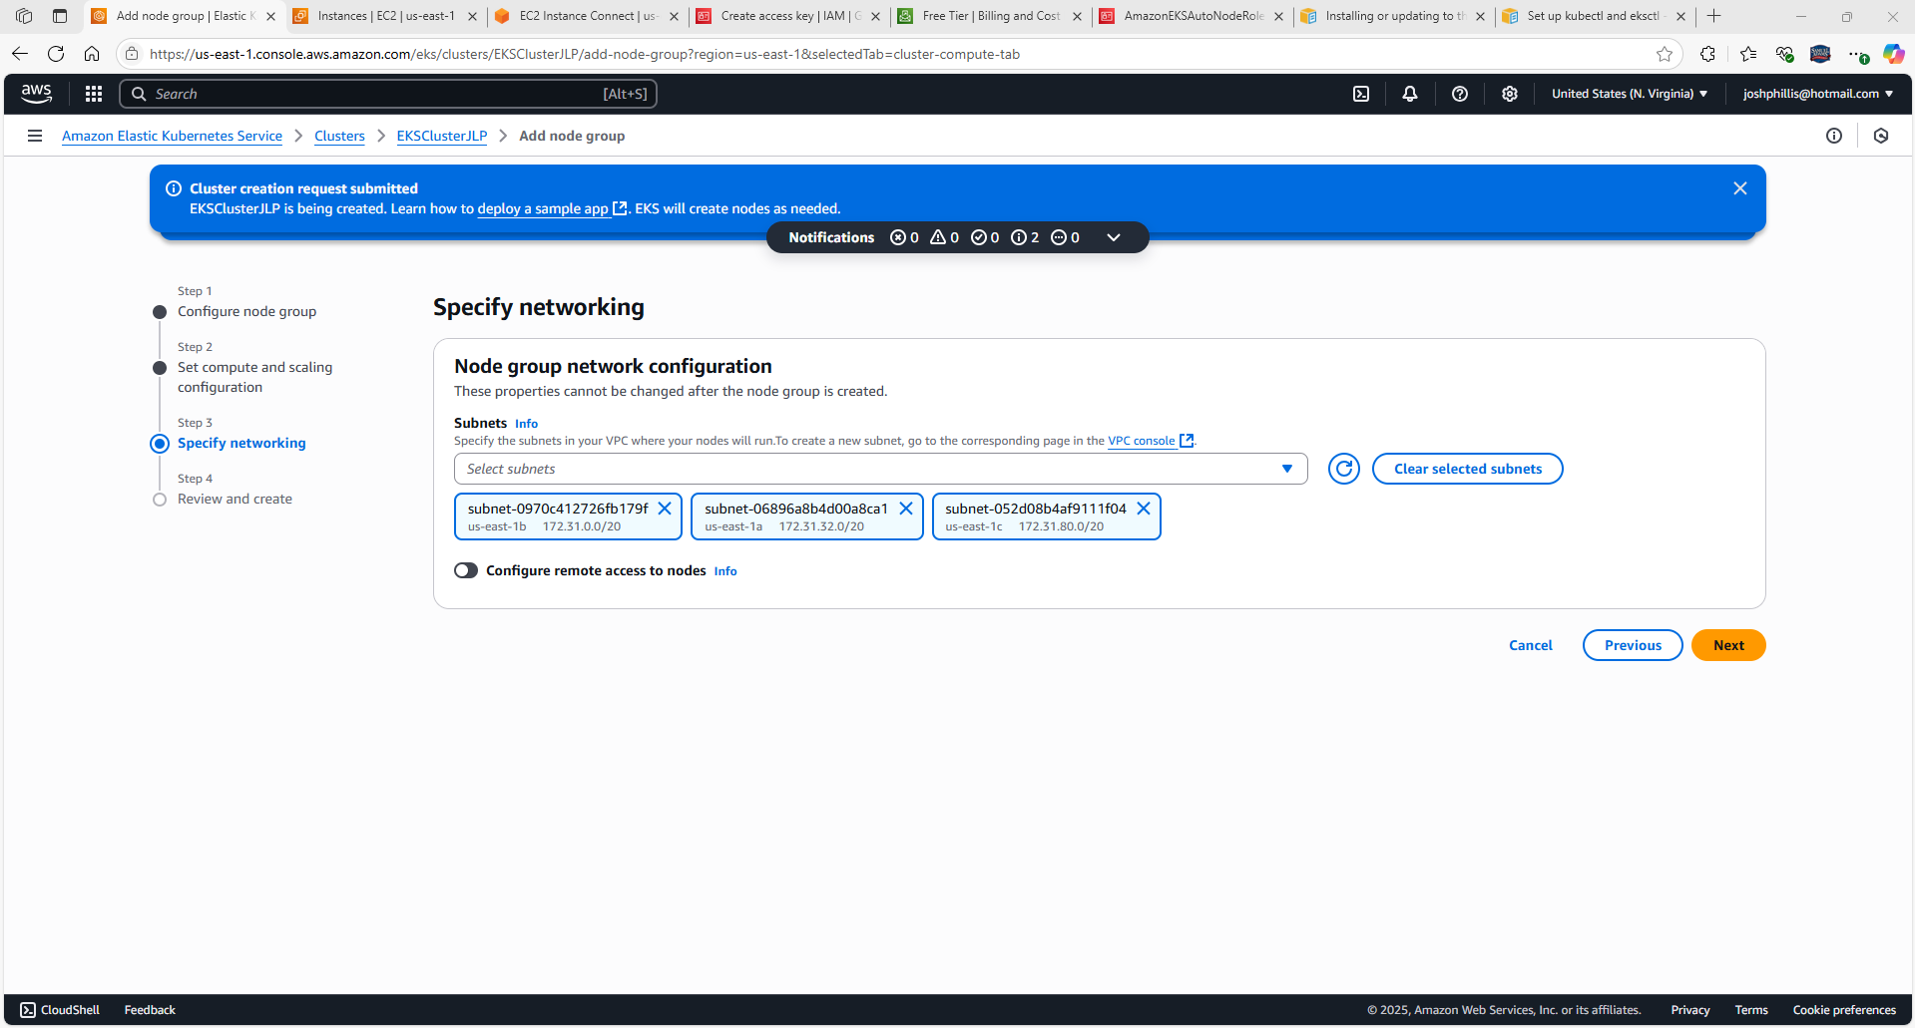

Select Enable

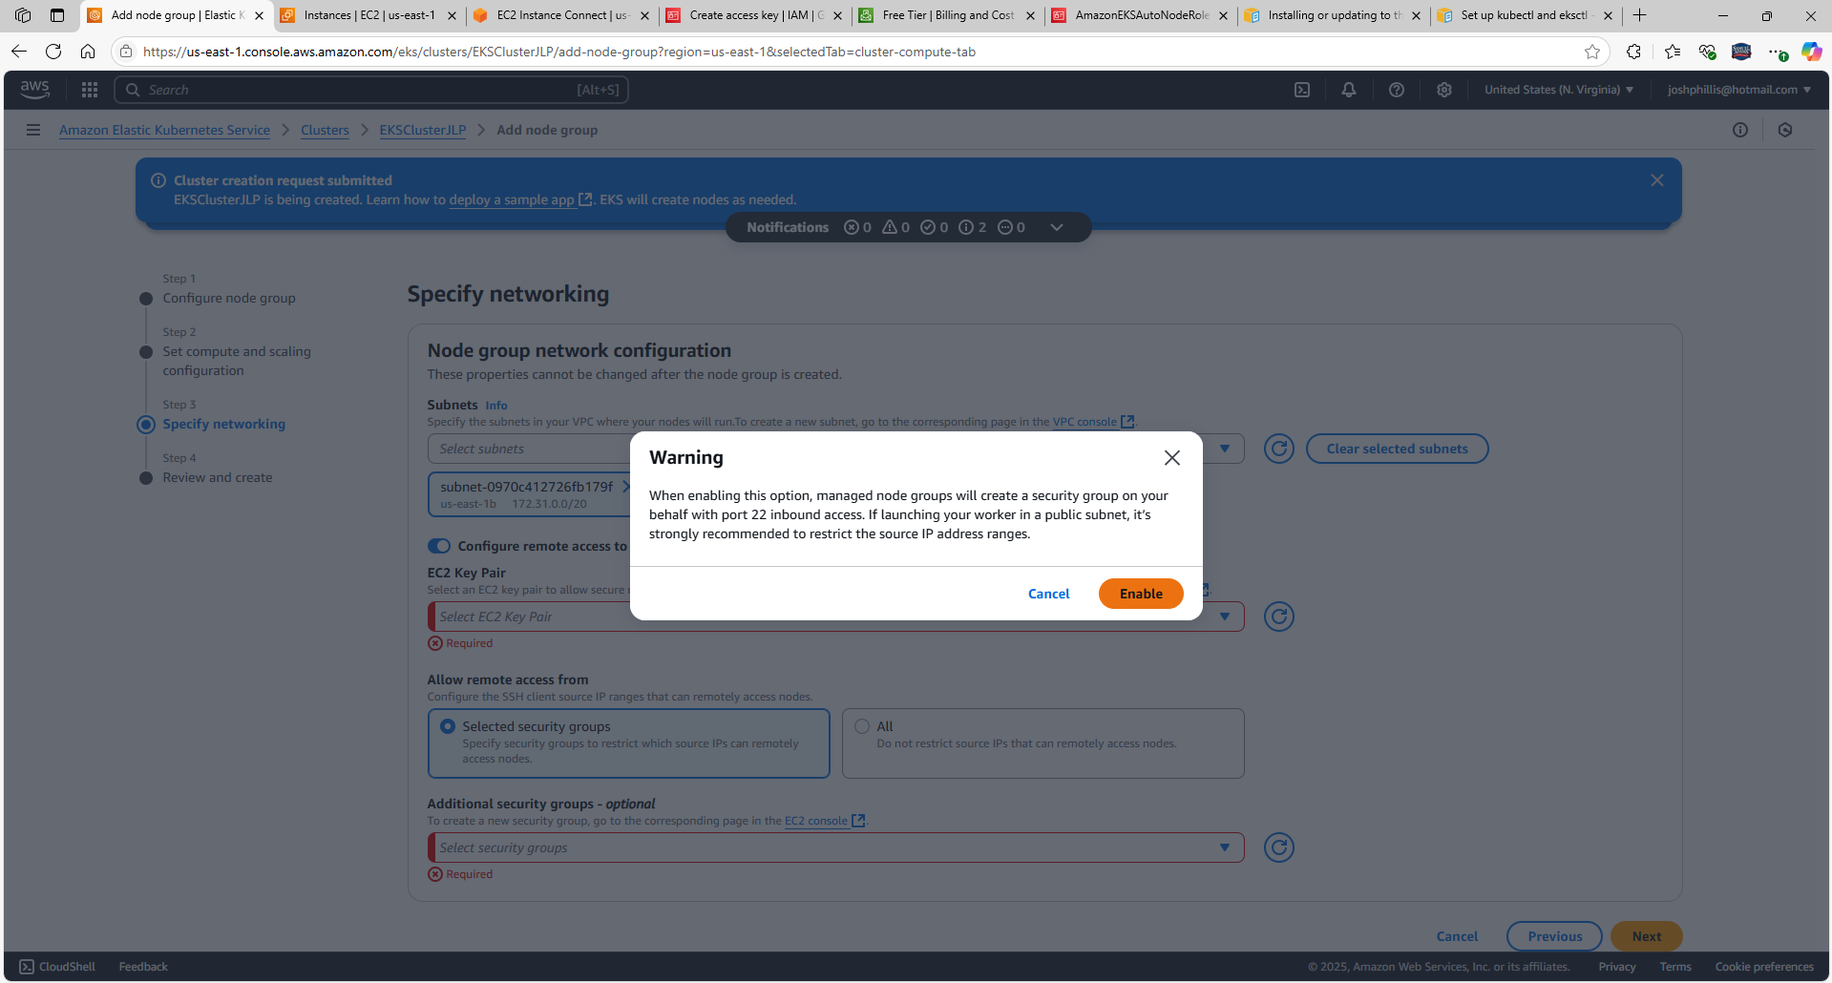

EC2 Key Pair: EKSCluster (created previously)

Allow remote access from: All

Select Next

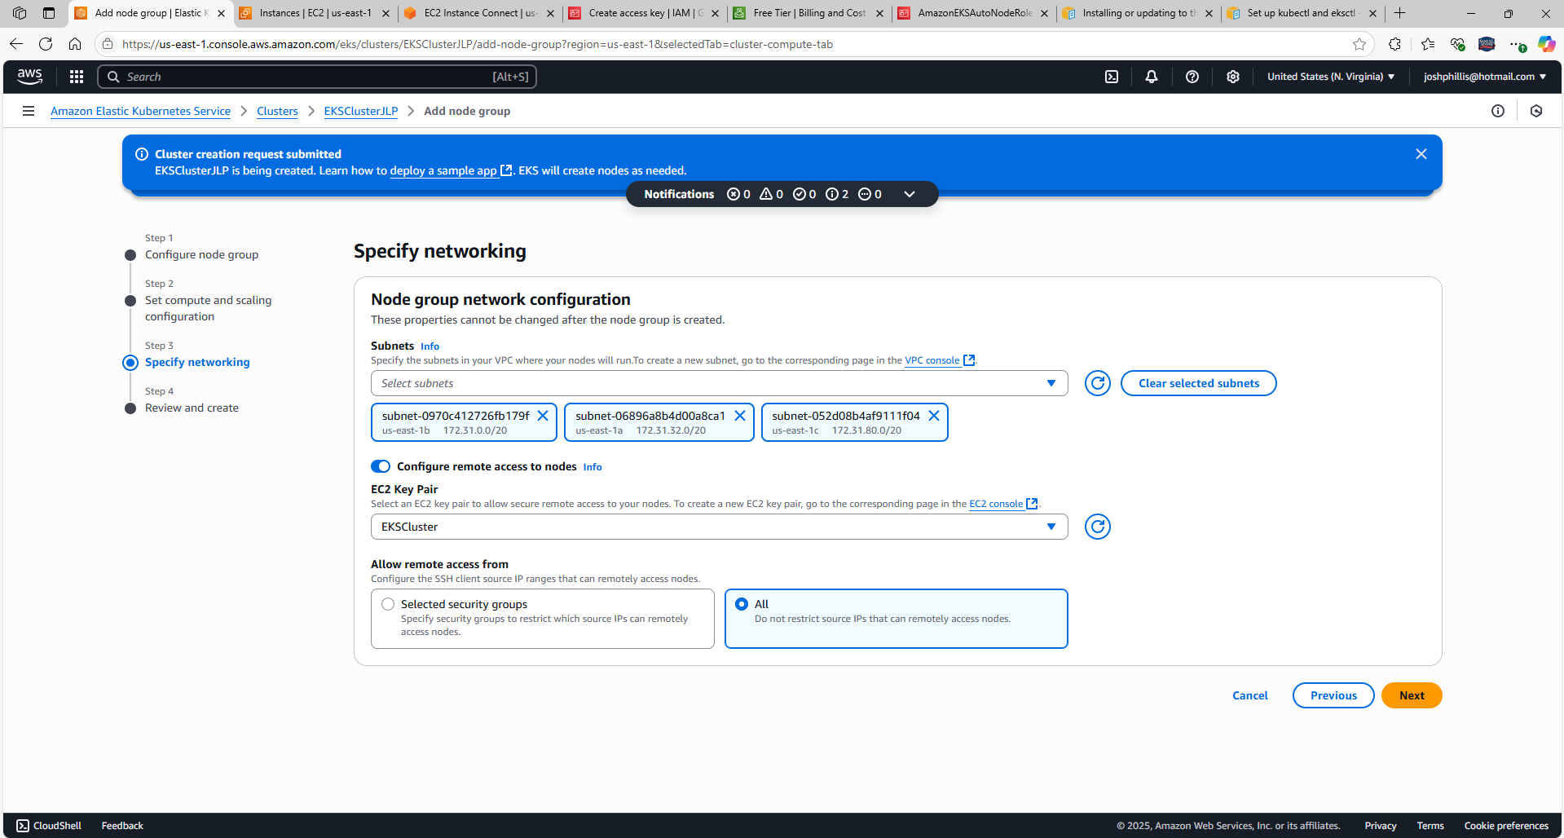

Scroll down, select Create

Had to adjust size back to 20 from 5

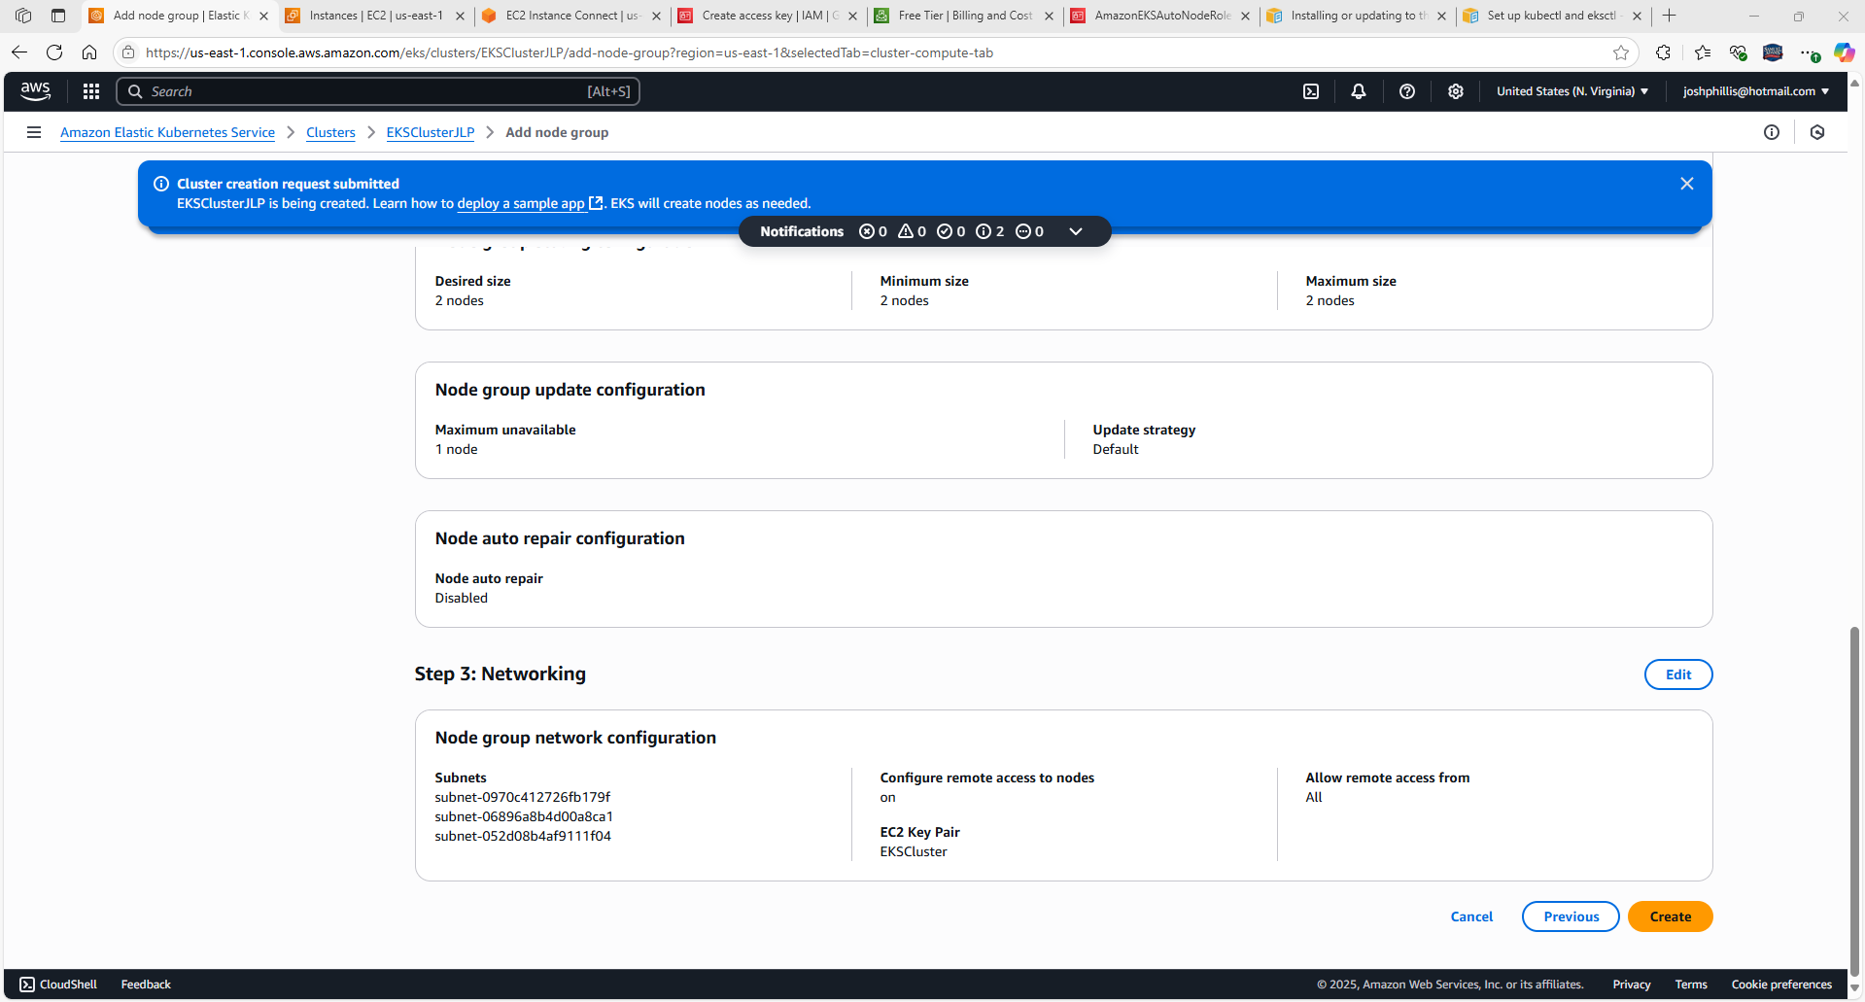

Enter **kubectl get svc** to verify if the services are running

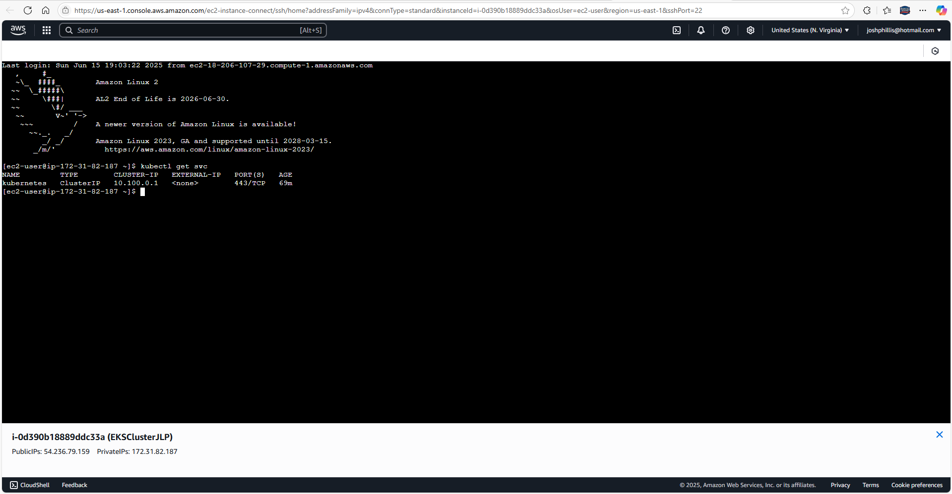

Enter **kubectl get pods –all-namespaces** to check the running pods

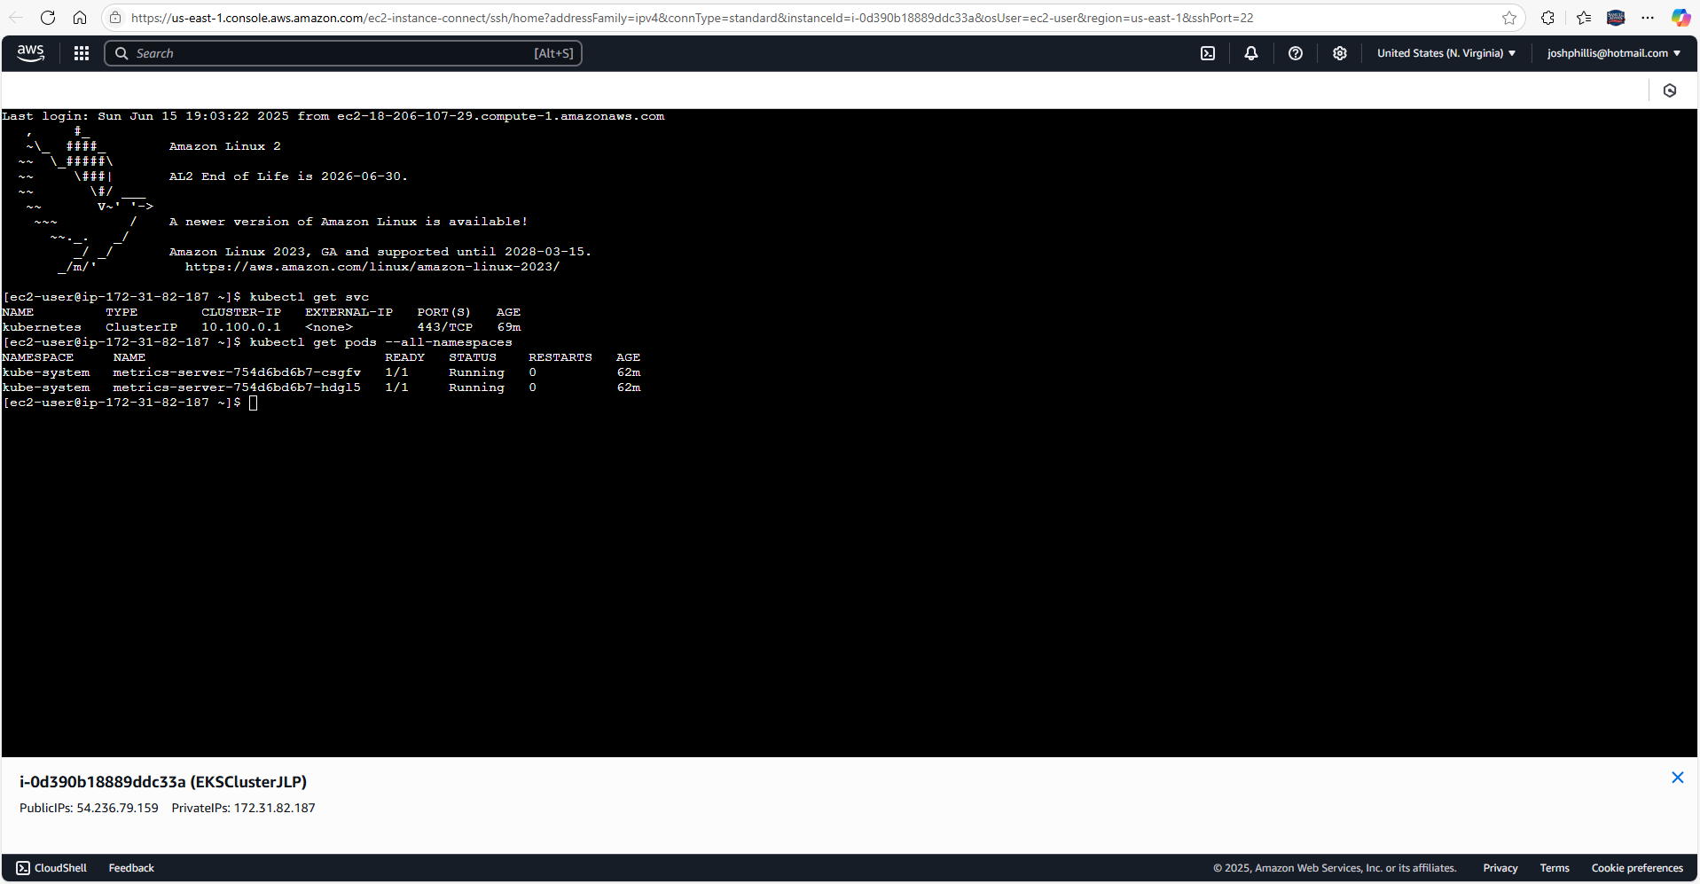

Enter **kubectl create deployment nginx --image=nginx** to test cluster connectivity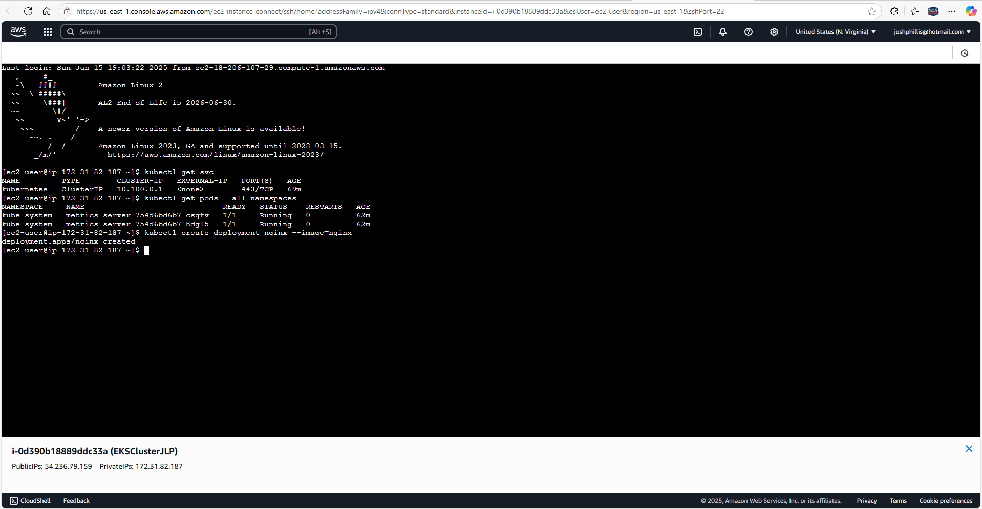

Enter **kubectl logs <pod-name>** which is **kubectl logs nginx-5869d7778c-rsb92**

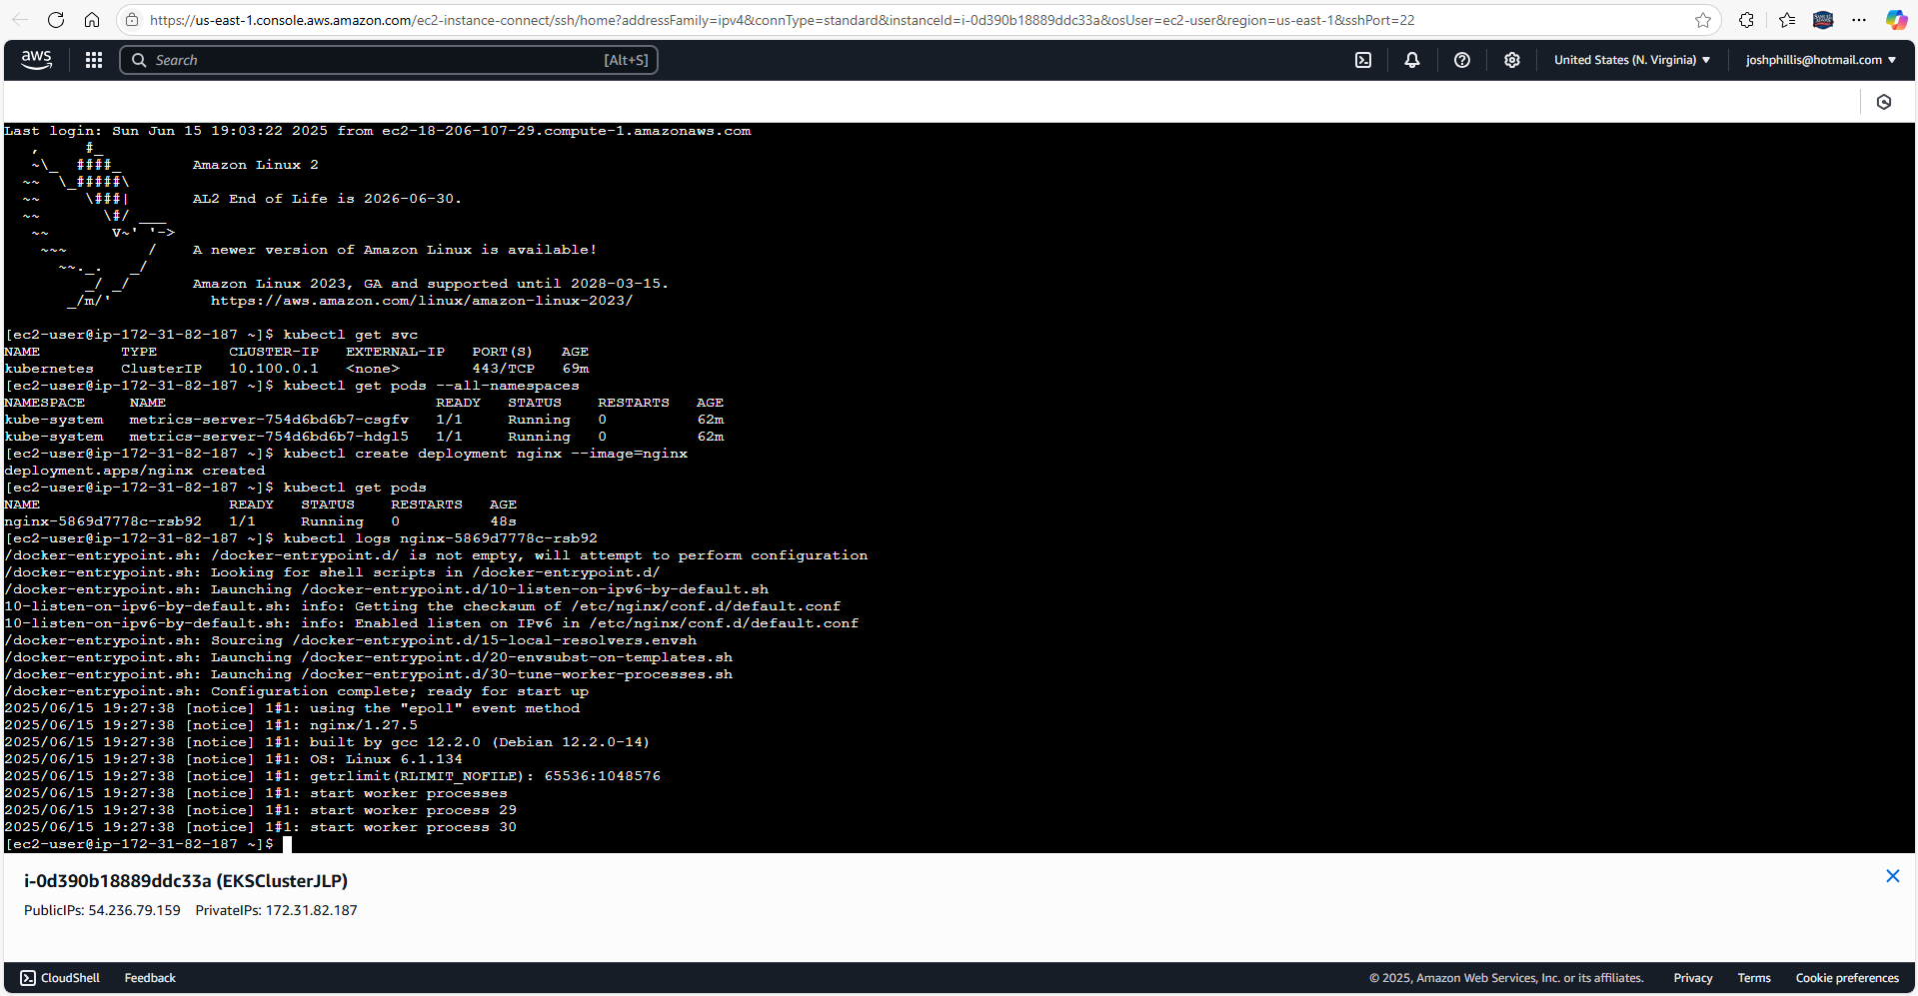

Enter **kubectl get pods** to confirm that it is running

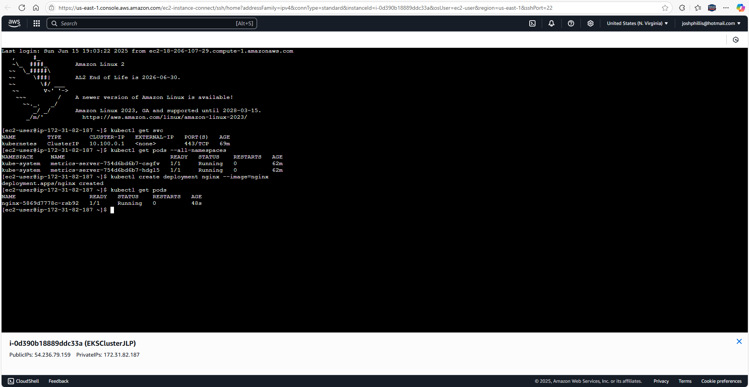



1. Delete the Failed Node Group

Run the following command to remove the failed node group:

**aws eks delete-nodegroup --cluster-name EKSClusterJLP --nodegroup-name myworkernodeJLP --region us-east-1**

2. Recreate the Node Group

Use the AWS Management Console or CLI to create a new node group:

**aws iam list-attached-user-policies --user-name <your-user-name>**

3. Verify Node Group Status

Once the node group is created, check its status:

**aws eks describe-nodegroup --cluster-name EKSClusterJLP --nodegroup-name myworkernodeJLP --region us-east-1 --query nodegroup.status**

4. Confirm Node Registration

Run:

**kubectl get nodes --watch**

**If nodes appear but are in NotReady, check logs:**

**sudo journalctl -u kubelet -f**

5. Restart EC2 Instances (if needed)

If nodes still fail to register, reboot them:

**aws ec2 reboot-instances --instance-ids <instance-id>**

Building a Scalable Amazon EKS Cluster: Challenges & Key Takeaways

Deploying an Amazon EKS cluster with EC2 instances and worker nodes was a journey filled with problem-solving and optimization. From IAM role permissions to networking configurations, every step required careful debugging to ensure the nodes registered correctly and workloads ran seamlessly.

* **Problem Statement:** Setting up an EKS cluster with separate EC2 instances while ensuring proper node group connectivity, IAM role configurations, and Kubernetes authentication.
* **Challenges:** Addressing Cross-account pass role errors, node group creation failures, missing aws-auth ConfigMap, and network misconfigurations preventing proper cluster registration.
* **Tools & Technologies:** Leveraged Amazon EKS, EC2 instances, IAM roles & policies, AWS CLI, Kubernetes (kubectl), and security groups to deploy a cloud-native infrastructure.
* **Outcomes:** Successfully created an EKS cluster, resolved node registration issues, optimized IAM permissions, and confirmed proper workload execution—all essential for a scalable Kubernetes environment.

This experience reinforced the importance of role-based access controls, secure networking, and persistent troubleshooting in cloud-native deployments. Have you faced similar challenges with EKS or Kubernetes? Let’s discuss!

**Deploying Amazon EKS with EC2 Node Groups and a Separate EC2 Instance**

**1. IAM Role Setup**

**- Create a role for the EKS cluster with the following policies:**

- AmazonEKSClusterPolicy

- AmazonEKSServicePolicy

**- Create a node IAM role with:**

- AmazonEKSWorkerNodePolicy

- AmazonEKS_CNI_Policy

- AmazonEC2ContainerRegistryReadOnly

**- Optionally add:**

- AmazonEKSBlockStoragePolicy

- AmazonEKSComputePolicy

- AmazonEKSLoadBalancingPolicy

- AmazonEKSNetworkingPolicy

**2. Install Required Tools**

**- AWS CLI:**

curl "https://awscli.amazonaws.com/awscli-exe-linux-x86_64.zip" -o "awscliv2.zip"

unzip awscliv2.zip

sudo ./aws/install

aws --version

**- eksctl:** Follow https://docs.aws.amazon.com/eks/latest/userguide/eksctl.html

**- kubectl:**

curl -O https://s3.us-west-2.amazonaws.com/amazon-eks/1.33.0/2025-05-01/bin/linux/amd64/kubectl

chmod +x ./kubectl

mkdir -p $HOME/bin && cp ./kubectl $HOME/bin/kubectl && export PATH=$HOME/bin:$PATH

echo 'export PATH=$HOME/bin:$PATH' >> ~/.bashrc

kubectl version –client

**3. Create EKS Cluster**

- Use AWS Console or eksctl to create the cluster.

**- Example CLI:**

aws eks --region us-east-1 describe-cluster --name EKSClusterJLP --query cluster.status

aws eks --region us-east-1 update-kubeconfig --name EKSClusterJLP

**4. Launch EC2 Instance (Separate from Node Group)**

- Use Amazon Linux 2 AMI (Free tier eligible).

- Instance type: t2.micro

- Allow SSH and HTTP traffic.

- Create and use a key pair (e.g., EKSCluster).

- Install AWS CLI and kubectl on the instance.

**5. Create Node Group**

**- In the EKS Console:**

- Go to your cluster > Compute > Add Node Group.

- Name: **myworkernodeJLP**

- IAM Role: **AmazonEKSAutoNodeRole**

- Disk size: **20 GB**

- Enable remote access using the EC2 key pair.

- Select 3 subnets.

- Launch the node group.

**6. Validate Cluster and Nodes**

**- Check services and pods:**

kubectl get svc

kubectl get pods --all-namespaces

kubectl get nodes --watch

**- Deploy a test workload:**

kubectl create deployment nginx --image=nginx

kubectl get pods

kubectl logs <pod-name>

**7. Troubleshooting Tips**

**- If node group fails:**

aws eks delete-nodegroup --cluster-name EKSClusterJLP --nodegroup-name myworkernodeJLP --region us-east-1

**- Recreate node group and verify:**

aws eks describe-nodegroup --cluster-name EKSClusterJLP --nodegroup-name myworkernodeJLP --region us-east-1 --query nodegroup.status

**- If nodes are NotReady, check logs:**

sudo journalctl -u kubelet -f

aws ec2 reboot-instances --instance-ids <instance-id>